**Hazard coursework NEA – Cameron McGregor**

# Table of contents:

**Analysis (1) - p.g 2**

**(1.1) Background / game mechanics – p.g 2**

**(1.2) Current systems – p.g 3**

**(1.3) My system – p.g 5**

**(1.4) End user testing / Research – p.g 7**

**(1.5) Objectives – p.g 8**

**Design (2) – p.g 10**

**(2.1) Setting up the game – p.g 10**

**(2.2) Fortify stage – p.g 16**

**(2.3) Attack stage – p.g 16**

**(2.4) Reinforce stage – p.g 20**

**(2.5) Winning – p.g 26**

**Technical Solution (3) – p.g 27**



**(3.1) Start-up menu – p.g 27**

**(3.2) Player class – p.g 29**

**(3.3) Country class – p.g 30**

**(3.4) AdjacencyListRegion class – p.g 30**

**(3.5) GameBoard form – p.g 32**

**(3.5.1) Instantiation of variables – p.g 32**

**(3.5.2) Setup and mouse click and enter functions – p.g 33**

**(3.5.3) Repeated and specific task functions – p.g – 39**

**(3.5.4) Functions for form control events – p.g – 43**

**(3.5.5) Functions for mouse enter and click events – p.g – 50**

**(3.5.6) Interface screenshots – p.g – 52**

**(3.5.7) Procedures and variables listings – p.g - 59**

**Testing (4) – p.g – 62**

**(4.1) Testing while programming – p.g – 62**

**(4.2) Test plan – p.g - 63**

**Evaluation (5) – p.g - 68**

# Section 1 – Analysis

**References used during Analysis for research-**

[**https://www.pogo.com/games/risk?sl=2&gamekey=risk#game**](https://www.pogo.com/games/risk?sl=2&gamekey=risk#game) **– To research the different computerised versions of Risk that were already available online.**

[**https://brilliantmaps.com/risk/**](https://brilliantmaps.com/risk/) **- To research the different maps that were available to use and give me differing ideas for other boards and rules that could be used for Hazard.**

**Hasbro Risk board game – Used this as a basis for my game to turn into the computerised version so will use the rules and mechanics from this as well as potentially the board as the map if I choose to go with the standard map.**

* 1. **Background / game mechanics-**

**My game that I aim to create I have aptly named Hazard (synonym of Risk from the already existing game) is going to be a computerised version of the very popular World Domination board game Risk. I play the board game risk a lot with my family and friends as well as lots of other similar strategy games on the computer a lot in my free time (games including Total War and Civilisation). These games are of a very similar nature but quite a lot more advanced in their gameplay than Risk is. I find all these types of games extremely interesting. For this reason, I have chosen to turn this board game into a program, as it is something I already have an invested interest in so will hopefully allow me to make it the best I can as far as visuals and gameplay goes. For turning this game into a program, I already know that I will need to heavily focus on the attacking, reinforcing and fortifying mechanics of all the different regions on each turn as these are the main functions of the game and are vital to get these working correctly and efficiently. During the analysis I will go through how I plan on making the mechanics from all aspects of the game in my program before actually attempting to make them in the technical solution stage. To do this I will run through all the mechanics and rules of the game while suggesting ways I could and most likely will implement them later on. I aim to create this game to be playable from 2 › 6 players inclusively from the standard ages of 10 and above with an interactive menu at the beginning of the game for selecting players and possibly even player names and colours that each person wants. However, this could just end up being that each player already has a pre-determined colour of the 6 original ones that you get with Risk and a random player will be chosen for deciding who will go first.**

**Risk is obviously a hugely popular board game and now with over 30 different versions, there is a lot of choice and variation in the game rules from a Lord of the Rings theme style to a just a Europe map all playing with slightly different rules with added extras. For my game Hazard I will most likely stick with the original most known Risk board, as is shown below along with all the original rules that complement it. Obviously, a huge problem I am going to have with this idea is a way of implementing the map so that players can interact with it and click all of the individual specific regions on the map, of which there are 42 of various different shapes and sizes. There are two ways which I could make this possible, the first being make all regions have ever so slightly different shades of a colour so that when that colour is clicked it links to that region object, however this would require creating an entirely new map and would likely decrease the visual quality of the map which is a key thing I want to get right. And so, that brings me to the second much easier solution which is just to place the clickable boxes available in c# (only shape useable are rectangles) in the nearest to shape I can create for each region or just in the middle of them and then if multiple are used just link them all together under that one region object using a tag. This way it would be very easy to program the individual regions but obviously at the cost of having areas you can click on that won’t register as a region as it won’t have any boxes there.**

**As of current, there are quite a few versions of Risk that are already available as online computerised versions of the board game which I have played to see what the current systems are already in place and any features I want to include or any I want to improve on.**

* 1. 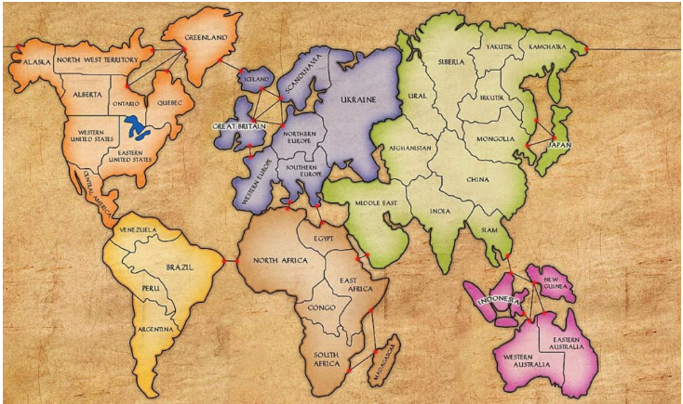**Current Systems-**

Figure .1

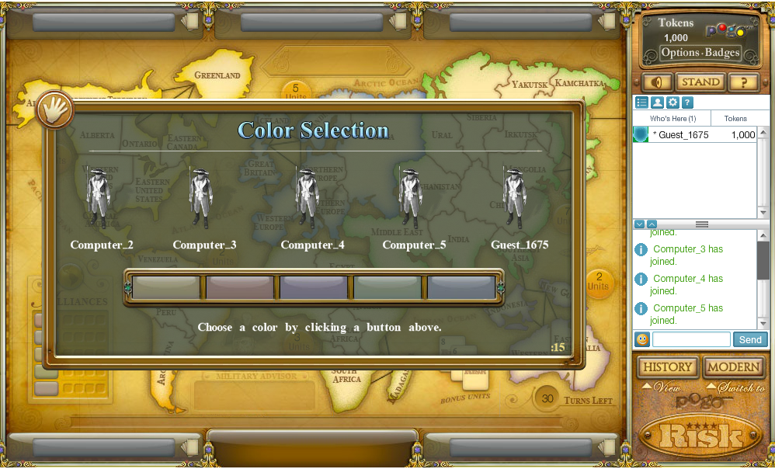**As previously mentioned, there are already multiple different computerised versions of Risk available online to play with a mixture of online and offline versions. I have play tested some of these current versions in order to see what they currently offer and any problems and improvements that I want to try and make in my system as well as any potential ideas I could try to include in my program. The first game I tried was an 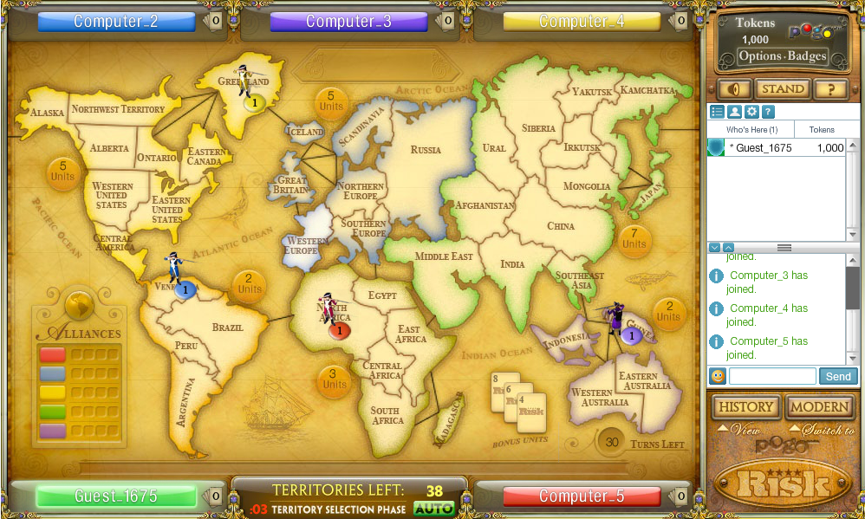online game however since that requires you to wait for the other players (I soon found this took a while to test) so instead I started a new game with A.I so that I could see the UI and program mechanics.**

Figure .2

Figure .3

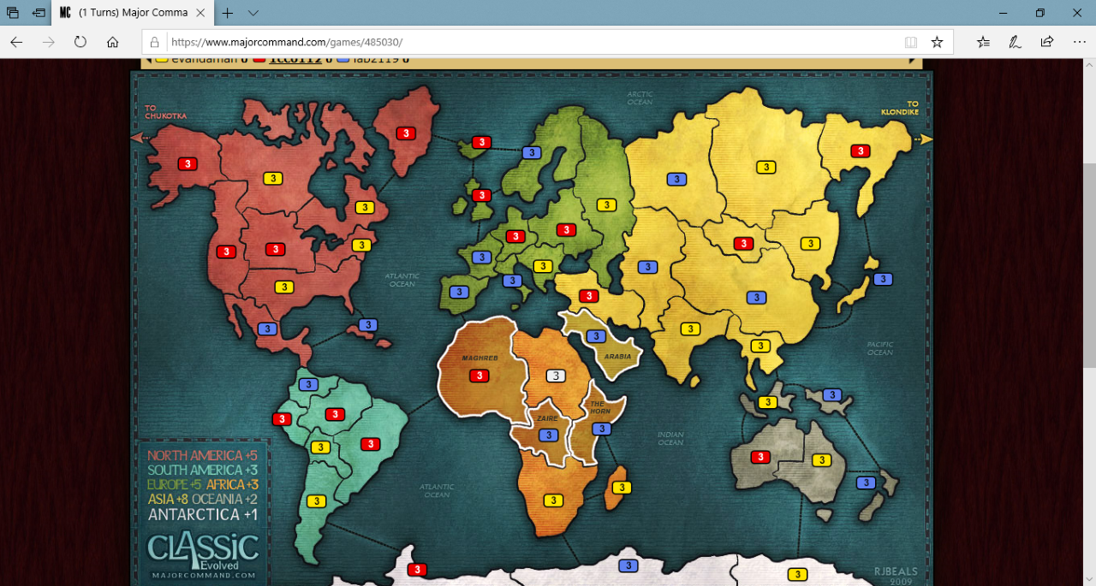**This first version had a lot of features which I was already planning on including within my game which was involving the UI of the main map. The territories would have a circle or square (coloured for each player) with the amount of troops in that area which is my aim to have in my program however for this one each person selects a specific colour rather than pre-set colours where the players just pick names (which is what I plan to have in my code). Another feature is that when you hover over an area it slightly brightens the area (highlights it) which is a feature I hope to add if possible so that navigating the map is easier. The only improve I would add a separate table to show the extra troops for the continents and also an option to open up the rules of Risk as well having the players and their colours in one area rather than spread around the screen.**

Figure .4

**The second game I tested was also online however as with before I play tested an offline version with A.I so that I could see the mechanics and UI that they have used.**

**In this version they had the same UI idea that I had for having the extra armies for each continent in one area on the screen and a much less crowded screen in general which I will try to replicate as to make it look more appealing and easier for players to navigate and understand. As well as this they have highlighted all surrounding areas of each region with the ones it can reach which if I am able to will also include in my program but might be quite difficult to do so.**

* 1. **My System-**

**In this part I will run through how a standard game of Risk plays through and how at each problem / game mechanic how I intend to solve it and implement it when I come to programming the game.**

**How the game works is that you play on a map/board that is split into multiple regions (around 42 in most versions). These are going to be an issue when creating the buttons in visual studio as only rectangular shapes can be made and so to counter this issue I am going to have to create multiple rectangles to best fit the irregular shape then give them all the same tag or just put a single box in the middle of the region. These regions are then divided into bigger areas of regions (continents) which contain from 4 › 8 regions in each. Each region is linked to all the surrounding regions that it can reach and in some cases over river, seas or mountains and equally can even be blocked by the things previously mentioned. A typical game can be played with 2 – 6 players which I intend to also incorporate into the game by allowing this option of players to be available. When the game starts each player chooses a name and is then given a colour of which I will have 6 available in the code to from – (blue, black, yellow, grey, red, green) but depending on the board some other colours may end up being more appropriate for the ability to see them. From there a random player will be selected to go first. I will just get a random integer between 1 › the number of players to determine this. Then going in a clockwise (or in this case numerical) order each player gets to place beginning pieces which vary depending on how many players are playing (20 pieces for 6 players, 25 for 5, 30 for 4, 35 for 3, 40 for 2). They each place one piece on a region in turn until all regions have been taken up. Once a player has placed an army on a region, I will have to have some way of visually representing this mainly the region button, either on its border or the main body, will be coloured their colour. I can either do this by colouring the troops/number of troops (the actual text on the button) or by colouring the entire region or region border in the players colour. When all regions are taken up each player can place their remaining pieces to back up or fortify the regions that player already have troops on. There are 3 different pieces that a player can use to represent their troops and can be used in any way they like so long as they add up to the same total number of armies. An infantry = 1 troop, A horse = 5 troops and an artillery gun = 10 troops. I can either visually represent players troops on the game using just numbers on each of the regions or using actual troop pictures. However, if I go with the single button approach, representing them as actual numbers as text will definitely be the preferred option. This will also make the game a lot more visually pleasing.**

**Next, I will outline how each of the phases within a player turn should work.**

**Fortify - Once the initial placement of troops has been done the setup of the game is complete and it may now advance to the player turns, starting with the player which placed their troops first. This will be pre-stored from when the random number was selected before. A player turn is spilt into 3 parts: Fortify, Attack and reinforce. The first thing that happens on a player turn is the fortify phase. This is where they get a certain number of troops to reinforce on the regions they already own and is calculated on how many regions they control (plus any extra troops for controlling all regions in a continent). This is calculated by getting 1 troop per every 3 regions that player owns and then a differing extra amount for any entire continents that a player owns. The default minimum on this is 3 so if a player has 8 or less areas, they will automatically get 3 troops to fortify with. These as previously mentioned can be placed together or separately on any or all of the regions which that players occupies. Once a player has completed the fortify part of their turn, they may then move onto the attacking phase.**

**Attack - For attacking phase on a turn the first thing that will need to be worked is out is which areas a player can attack from their controlled areas. Already I know this will be one of the hardest things to do within the program as it will involve setting up either an adjacency list or an adjacency matrix within the program. However, I will have to research into both methods and find out which is the best option for linking all he regions together. However, considering the amount of connections between nodes being one node connecting to the surrounding ones the most likely option will be the adjacency list. After this, a player can choose one of their regions that contains more than 1 troop in and choose to attack a connecting region. They can then choose to attack (if available) with 1, 2 or 3 armies of which the defender defends with (x – 1) armies with a minimum of 1 troop. Then once a player has selected the attacking region and which other region they want to attack and with how many troops (1 › 3 simulating the dice rolls) a D6 dice is rolled for each defender army and each attacker army. On the program this will be simulated by a random number generator for each army either attacking or defending.**

**The rules for attacking are that when the die rolls are placed in order for example with the attacker rolling 5, 2, 8 and the defender rolling an 8 and a 1. The 8 and 8 would be compared then the 5 and 1. If the die are the same then the defender gets the advantage and one of the attacker’s armies are destroyed and for the second highest the attacker has the highest roll so one of the defender’s armies would be killed. If the defender’s armies are reduced to 0 the defender moves into the space with the amount of troops they decided to attack with. This can be anything up to the (total troops – 1) as 1 troop must be left on the original region they attacked from. If the attacker loses all their attacking troops, they can either (if they have more troops available) attack again, or if they don’t the attack will be stopped. Alternatively, the attacker can stop after any dice roll and concede the attack. As many attacks can be made by the attacker as they want until they end their attacking phase. Once this is done the reinforcing phase of their turn begins.**

**Reinforce – Once the player has finished their attack phase, they may then reinforce their regions if they wish. This can only be done once per turn and involves the player moving troops ( 1 › (max troops in that region – 1)) from a region with more than one troop currently in it into any adjacent region that has a connected path to it that they already own. This will be worked out using the adjacency list and may even possibly have to have an implementation of a tree to see if a path can be created from one area to another.**

**Once this phase has been completed this marks the end of a players turn and the next players turn begins at the fortify stage of the turn cycle. A player is eliminated from the game once all their troops have been removed from all the areas that they occupy, and a player wins the game by doing this to all other players until they own every region on the board.**

**Since the game board is split into 42 different regions (or a similar amount of regions depending on the map) I will need to implement within the code an adjacency list to be able to represent the visual connection of the regions and which link to which in a program format. This is so that phases such as attacking, and reinforcing can be performed. Since each region only will have a maximum of 6 connections to the surrounding regions, I think the best option to go with would definitely be an adjacency list as overall the graph is very sparse of connections with 2 being the minimum and 6 being the maximum so nodes will only ever connect to surrounding ones and wont g near the other 35 or so regions.**

**In the program I would also definitely store the regions and players as classes. This is because for the regions (areas) on the map they must store not only which player currently occupies it but also how many of that players troops are in that region. The players will also need to be classes as they have to contain a lot of information. This includes what regions they occupy, what colour that player is, the player name and the troops they have to place during the initial setup of the game and the fortify stage. The troops they have in their occupied regions and which they occupy will already be stored in the region class and so that will need to be searched through a list of the class country (in the player class) and find all the regions that player occupies in order to be able to use that information when it’s their turn**

* 1. **End user testing / Research-**

**For my end user testing I will need to have 2+ people that will need to run through the game and play it. Thus far I have a group of 5 to play the game in my friendship group who also helped to complete the survey and give their advice on what they definitely want in the game (Calvin Jubb, Alex Towers, Brandon Thompson, Vanessa Lace, Lydia Ferris), my brother Rory and a few of his friends and some other family members who were also interested in being an end user tester for the final game as they already enjoy playing the board game.**

**For the initial research of my game I have created a survey on Survey Monkey and posted it to Facebook (so my family can access it) and also posted it online at survey monkey to gather information on how much people play or are interested in playing a Risk type computer game and what features they deem most important so that I can focus more heavily in these areas within the design stage and later technical solution stage.**

**Below I have summed up the main feedback from each question answer from the 7 people who have answered the survey and have used this throughout my design to help me formulate my objectives and the overall structure of the program. The main point I got from it technical wise was that the game would be easy to navigate and to use and so this is something I will be heavily focusing on when creating my program.**

**1 - Do you play video games?**

**Mainly yes (6/7)**

**2 - Do you play board games?**

**Average (4/7)**

**3 - Have you ever played the game Risk (world domination)?**

**Mainly no (3/7)**

**4 – If so, would you be interested in playing it as a computer game?**

**Optional question on survey monkey all yes (3/3)**

**5 – Would you most likely play it or other games with friends or family?**

**3 answered family, 1 answered friends and the other 3 answered both**

**6 – For you what is the most important aspect of a video game?**

**Main answer was the visual side and it being easy to use and navigate**

**7 – What would be the most important part to get right with a risk type game in your opinion?**

**Main consensus what that it ran smoothly and was easy to use**

**8 – Would you prefer to have the normal risk map or an alternative map?**

**(5/7) said they would prefer the original map the other 2 suggested LOTR map and the other didn’t specify an alternative map**

**9 – Would 3 players in your opinion be enough to play Risk?**

**(6/7) said yes, the other suggested a minimum of 4 players to play Risk**

**As can be seen from the people that answered the questionnaire, having a game that is visually good looking and easy to navigate seemed to be a top priority as well and that the game was easy to use and navigate around. As well as this over half said they would prefer the original game map which is perfect as is the one I was intending on using anyway. Obviously, a massive constraint that I will have is that due to me making this program by myself and me not being the artiest person, the graphics will not be as impressive say as the other computerised risks. However, saying that I can still make it easy to use and navigate the game UI. I think this is something that current systems have a huge issue with. Even me, being someone who plays lots of video and risk like games, found some of the UI’s for the existing programs to be very complicated and almost overcrowded at times thus will be a big focal point as I go through creating this program.**

* 1. **Objectives-**

**Listed below are my objectives for the program including for the different mechanics (with how I wish for them to work) as well as incorporating any additional things such as visual ease etc. Anything in red is an optional objective that I will aim to add but is not necessarily a must have. (These are also underlined for printing in black and white)**

1. **Make a starting menu for the game**
   1. **Easy to navigate and click menu buttons to get either into a new game or to quit the program or to click help which will display the rules of risk and how to use the program**
   2. **Options buttons for new game, to quit and help that are clear and able to click**
   3. **Has the game name at the top of the screen with a suitable background**
2. **Make player selection**
   1. **Once new game has been selected the menu needs to have an option to choose the number of players (2-6)**
   2. **Once number of players has been selected each can then enter a name and then click again an easy to navigate button to start game**
3. **Load up the game**
   1. **Game needs to load up the map (whichever that ends up being, most likely the original one) in a presentable looking format which is easy to understand visually**
   2. **Have the buttons at the top for starting and ending turns**
   3. **Have the players with names and colours somewhere on the map that has an empty space available**
   4. **Have a visual aid on each area showing which player currently occupies it and how many troops it has on it**
   5. **Have somewhere that shows how many turns have been played (starting on 0)**
   6. **Needs to randomly choose out of the players that have been selected which will go first and then the order of the rest of the players**
4. **Game set up**
   1. **Needs to calculate (depending on the number of players) how many troops each player gets to place at the beginning**
   2. **Cycles through the players allowing each to place 1 troop on an unoccupied region**
   3. **Once a player has placed a troop on a region it needs to register this area as belonging to that player (done within the region and player class)**
   4. **Will need to have a visual aid to be able to identify which areas belong to which player (possibly using the player colour)**
   5. **Within the region class, add that 1 troop has been placed in that region**
   6. **Register once all regions have been occupied and then let each player in turn place remaining troops on regions that they already occupy**
   7. **Within the class add the number of troops in it depending on how many each player adds**
   8. **Finish the set-up phase and begin the game**
5. **Player fortify phase**
   1. **First must calculate how many troops the player will get (minimum of 3 unless (number of regions occupied / 3 is higher). Then any extra for entire continents that they occupy.**
   2. **Ability to click the regions which they already occupy (which will be visually represented using that players colour) and add the extra troops to them**
   3. **Have a button to click to end the fortify phase and begin the attack phase.**
   4. **Have a button to click to restart the fortify phase if a player makes a mistake(optional)**
6. **Player attack phase**
   1. **First must allow a player to click any of their regions that can attack another players’**
   2. **Then must allow the player to click any conjoining regions (which will be calculated using the adjacency list) to select to attack (the regions they can attack will be visually represented somehow probably by using a small green dot to show where they can attack or by greying out those that cant)**
   3. **Must then allow the player to select how many troops they want to attack with (the amount this can be must be, calculated depending on how many are in said region)**
   4. **Random die rolls must then be simulated for the attackers and the defenders (1 less than the attackers unless they are attacking with 1)**
   5. **Die rolls must then be compared and troops that are killed calculated**
   6. **After an attack the attacker should have 2 options to carry on attacking or to end the attack**
      1. **If they carry on attacking this repeats itself until either the attacker or defender have 0 troops left**
      2. **If the defender wins both players keep their territories with however many troops are left**
      3. **If the attacker wins then they move into the area with the remaining troops they chose to attack with after the attack has finished**
   7. **The player can attack however many times they want following this routine until they click a button to end their attack phase and begin their reinforce phase.**
7. **Player reinforce phase**
   1. **Player can reinforce once which involves selecting one of their areas and moving any number of troops (as long as 1 troop is left) to another adjacent region**
   2. **This will use the adjacency list to work out from a selected area which other ones can be reached (shown visually possibly by either a green dot or greying out the other colours)**
   3. **Will need to then allow the player to select the number of troops that they want to move**
   4. **Button to end reinforce phase that will begin the next players turn at the fortify phase**
8. **Game winning conditions**
   1. **Once a player has been eliminated it needs to stop cycling through them on turns**
   2. **Once all players have been eliminated but one it needs to display that that player has won the game and come up with a winning screen then end the program**
   3. **Quit back to the main menu (optional)**
   4. **Save winning players name and how many turns it took for them to win in a text file (optional)**

# Section 2 – Design

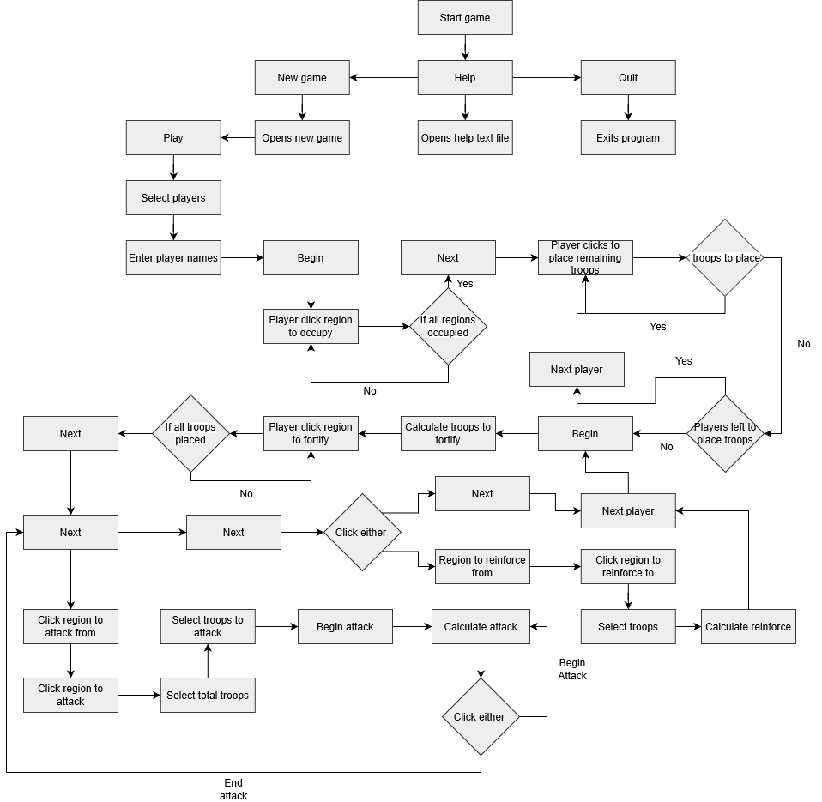**For the design section of my coursework I will break my program (which is being made in a windows form application) into five distinguishable parts and then run through separately as I also code them. The algorithms for key sections and mechanics of each part will be shown and an outline of how I intend to code and implement each section while incorporating my objectives throughout. The 5 ways it will be split is; Set up of the game (including the main menu and play screen) , Fortify stage of a players turn, Attack stage of a players turn, Reinforce stage of a players turn and then finally winning conditions for a player to win the game.**

**The first thing I have done below is created a top down design diagram for the program which is displayed to the right.**

Figure 2.1

* 1. **Setting up the game-**

**For the setup of the game it will open initially with the main menu screen. This will then have 3 options to either play a new game, quit the program or go to the help section. If possible, I will also have an option to open the file where the high scores are all stored. (optional) I have made what I want the main menu screen to look like using the colours of the Hazard logo to make a simplistic and clear menu for users to use. When the new game button is clicked the program should open a new screen (On the game board) and begin to run the game. Secondly when the help button is clicked a text file should be opened and its contents be displayed on the start menu. This should then have an option to close the help menu and go back to the main menu. Finally, the quit button should end and quit the program.**

Figure 2.2

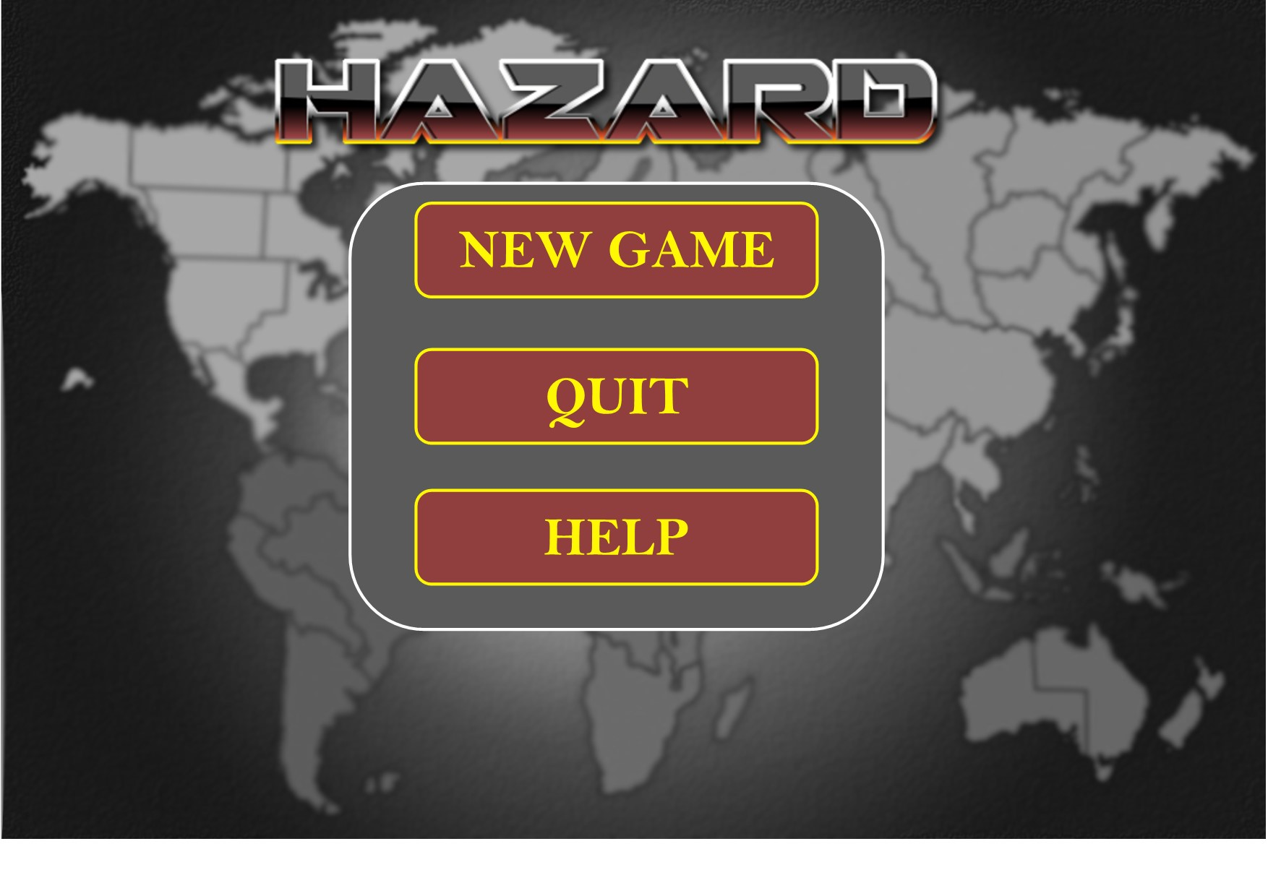

**As you can see, I have blurred out the game map to use as the background with the logo and buttons that the user will be able to click clearly in the foreground. The first thing that will need to be implemented is buttons for each of the boxes that will carry out the intended functions. A general algorithm for this menu looks like this.**

**WHILE ((quit button) has not been clicked) THEN**

**IF (button (new game) is clicked) THEN**

**open the play screen**

**run a new game**

**ELSE IF (button (help) is clicked) THEN**

**open file with rules for risk**

**ELSE IF (button (high scores) is clicked) THEN**

**open file with all players high scores on it (optional)**

**The first thing I need to do is code the boxes so that when clicked they all have the desired effect (Going to the game board for a new game, quitting and then displaying the help menu (By going through the file path to the text file). After this I need to create the UI for the play board and where the buttons go before beginning to program the actual game.**

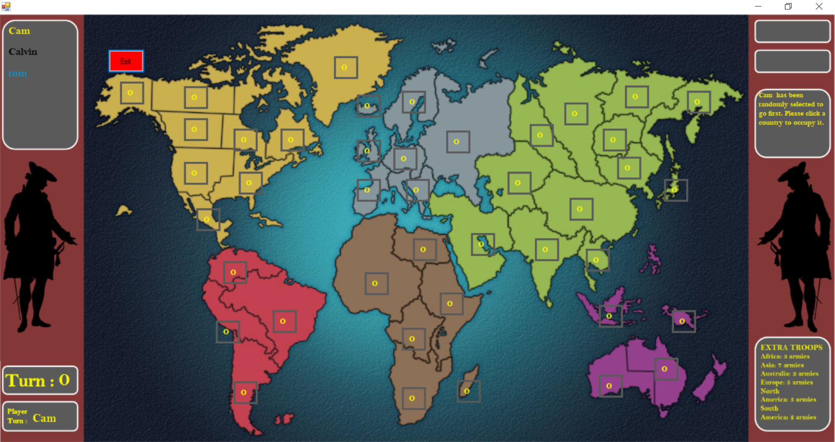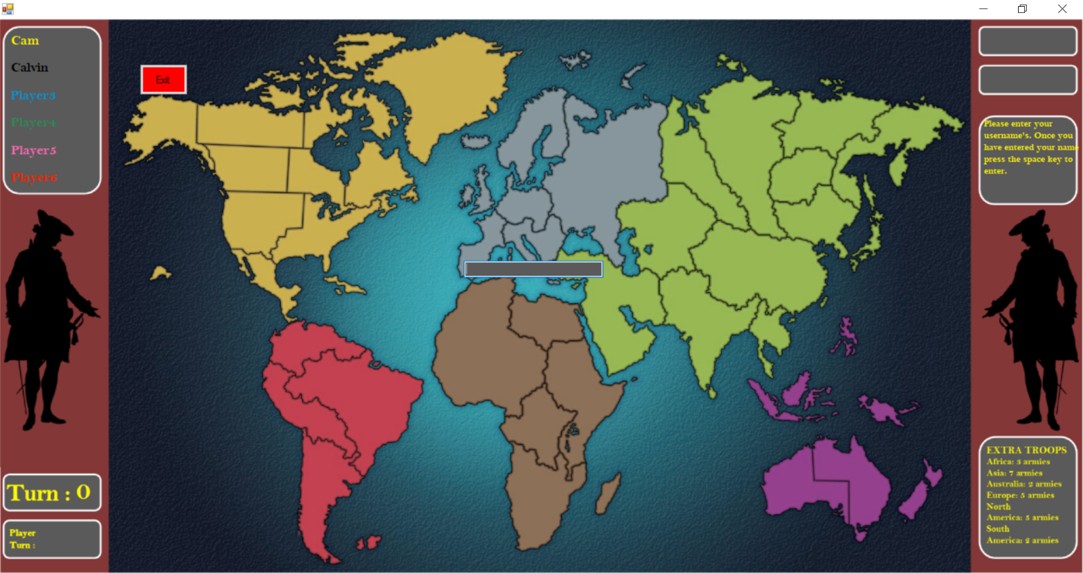**Once a new game has started the program will then open the game board screen. I have chosen a map that the game will use however there is still added bits that need to be included on this map UI. For instance, the turn counter, players and colours and whose turn it currently is as well as possibly a box showing the extra units gained for each whole continent that a player occupies.**

Region buttons

Figure 2.4

Help text box

Enter players name

Current players turn

Turn timer

Player name’s

Figure 2.3

**As you can see from figure 2.2 & 2.3 above the Ui will look something like this (excluding the exit button which is there to exit the game during testing). To the top left will display the players’ names and be in the colour of each player. To the bottom left there will be 2 text boxes one displaying what turn the game is on and the other which player’s turn it currently is (This will also be in the colour of that player).**

**The buttons for each region will have 3 functions. The first, being to display how many troops are on each region, the second being the border coloured in the players colour which currently occupies it and thirdly the inner box colour either red or green during a player’s turn to show where they can fortify, attack and reinforce. Finally, to the top right are where the begin and end turn buttons will be located, and to the left is a help text box which has a brief description of what the players must do next to advance the game.**

**A general algorithm for the setup of the game will look something like this. Once the players have entered their names (depending how many they’ve selected to play) it will display them on the board for visual ease (this will be the top left corner). The game will then start looping through the players allowing them to place their units until all have been places.**

**WHILE (n != 2-6) THEN**

**OUPUT (“how many players will be playing from 2-6?”)**

**n = USER INPUT**

**FOR (n amount of times) DO**

**OUTPUT (“what do you want to have as your player name?”)**

**Player n name = USER INPUT**

**IF (amount of players = 2) THEN**

**Units per player = 40**

**ELSE IF (amount of players = 3) THEN**

**Units per player = 35**

**ELSE IF (amount of players = 4) THEN**

**Units per player = 30**

**ELSE IF (amount of players = 5) THEN**

**Units per player = 25**

**ELSE IF (amount of players = 6) THEN**

**Units per player = 20**

**Random = RANDOM NUMBER (2 – amount of players)**

**WHILE (Units per player != 0) THEN**

**FOR (each player (starting with the one selected with the random number)) DO**

**OUPUT (“Place your troops”)**

**## Here they select a territory to place their troop**

**## Each time the program will check if there are any empty spaces left**

**IF (unoccupied territories != 0) THEN**

**IF (units on territory == 0) THEN**

**units on territory = units on territory + 1**

**player occupying = player**

**ELSE THEN**

**OUTPUT (“this territory is already occupied please select another one”)**

**NEXT player**

**ELSE THEN**

**OUPUT(“please place your remaining units on the territories that you already occupy”)**

**FOR (each player (starting with the next one in order)) DO**

**## allows each player to place a troop on one of their territories**

**For the creation of variables, which will be used throughout all 42 of the button click and mouse enter events for each of the controls in the windows form, I have set up public static variables to pass them through each of the 84 different functions for the buttons. To do this without using this method would require me to start changing the pre-set code for the button event functions and so I decided to stick with this method.**

**For the setup, once the user has clicked the play button on the game board, this will initialise the initial setup of the game. The first thing that must be done here is to select the number of players that will be playing (2-6). This could very easily be done by inserting a drop-down box for the user to choose the number of players from. The program would then need to read the users input and then store the number of players in a variable that could be used later in the setup. The next stage in the setup process is to then to ask the user defined number of players to enter their names. These will then be stored in the upper left-hand side of the game board screen and also in the player class items. From here comes the actual placement of troops onto the regions in the program. To do this, we need to first split each region up into objects of a region class and also to assign each player to an object of a player class. Setting this up to be implemented throughout the code I know will be a difficult task as they have to include many different attribute and methods within each.**

**At the beginning to attempt to solve the problem of being able to click each region individually I began by cropping out each region and trying to have it as a defined button. However, after a lot of research and trial and error, I realised there wasn’t any way to make a shaped button as intricate as the region’s borders are. Because of this, I decided to go with a slightly easier method of having a box in the middle of each region which could be coloured to display its state then contain a number showing the troops contained within while having in the code each region as an object of the region class.**

**To begin I must make the 2 classes I will need, the player and the region class. The class descriptions and diagrams follow as below. All the fields will be private except the list of occupied regions in the player class as this needs to be searched through and added to from different parts of the code frequently and methods public so these will be used to change the fields(attributes).**

|  |
| --- |
| Class description for Player class |
| String Player Name – Represents the user defined name for this player |
| List<string> Occupied Regions – Represents the regions that the player currently occupies |
| Array(string) Player Colour – Stores the rgb values for the colour of the player |
| Int Troops To Place – stores how many troops a player has to place |
| Method Player(name) – Creates a new instance of the Player class with the user defined name |
| Method Add Region(region) – Adds a region to the list of occupied regions |
| Method Remove Region(region) – Searches through the occupied region list and removes a region |
| Method Set Troops(troops) – sets how many troops a player has to place |
| Method Add Troops(troops) – adds troops to a player’s troops to place |
| Method Output Troops – returns the troops-to place attribute |
| Method Output Colour – returns the player colour |
| Method Output Player-Name – returns the player name |

|  |
| --- |
| Class description for Region class |
| String Name – represents the regions name |
| Int Troops – Represents how many troops occupy the region |
| String (changed to Player class later on in coding) Occupier – Represents which player currently occupies this region |
| Method Region(name,playername) – Constructor method that creates a new instance of the region class with the region name and player that occupies it |
| Method Change Occupier – Changes the player which occupies the region |
| Method Add Troops – Adds troops onto the region |
| Method Remove Troops – Removes troops from the region |
| Method Output Name - Returns the name attribute |
| Method Output Player – Returns the occupier attribute |
| Method Output Troops – Returns the troops attribute |

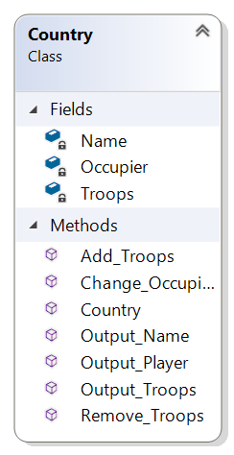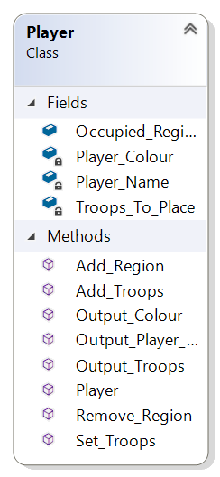

**Once the begin button has been clicked the program will then first roll a random dice from 1 - (number of players) to decide which player will begin. Then it will loop through the players allowing them to place their starting troops on empty regions. A feature which I also intend to make the UI easier to navigate, is that when you hover your cursor over a territory it will either highlight one of a few colours.**

**If it is the beginning of the game, then they will all be grey borders and highlight grey. Once a player occupies a region, the border will change to that players colour making it much easier to see who occupies which region. This will firstly happen at the beginning during the initial setup of the game. After the begin button has been pressed, the region icons will appear, and the program will randomly select a player to begin. After this, each player in turn will then need to select the regions to occupy. The current players turn will be signified by the Player Turn text box on the lower left cycling through the players’ names as each region button is clicked during this initial setup stage.**

Figure 2.6

Figure 2.5

**When a region button is clicked, it will need to do quite a few things including; change the border colour to the players colour; add 1 troop to that region ; iterate 1 down from the Remaining Regions variable (will be set at 42 to begin with) and instantiate a region object from the region class with the region name and player that wants to occupy it. When the initial regions have all been occupied the program then needs to move onto the next stage of the troop placement (Placing the remaining troops). In doing this I can see two big issues coming up.**

**The first of them being the program needs a way to be able to know when to move to the next stage once for example all the initial troops have been placed. One way of doing this could be to have a timer that runs after the initial troop placement starts that keeps ticking, checking if all regions have been occupied. Then when this condition is met it will move to the next stage in the program. A second issue is that when clicking and hovering the cursor over the region buttons, they will need to preform different actions at different times in the program depending on which stage it is in and this is a huge issue.**

**To solve this, I plan to have an enumerated type that has set values for each of the different stages of the program and then have multiple “if” loops within the mouse click and mouse enter functions to tell the program to preform different tasks at different stages within the game these will be as follows:**

**Place Troops Initial, Place Troops Remaining, Fortify, Attack Initial, Attack Player, Reinforce and Reinforce Move**

**After the remaining troops have been placed a checking system will need to be in place so that once completed, the program can move onto the next stage, which will then be the actual players turns. Throughout all of this, I will need to use 42 different region buttons and so it is and would be vital to me to find code that could be placed inside a function as to avoid repeating it 42 times for each of the separate mouse click and mouse enter functions.**

* 1. **Fortify stage-**

**Once all the troops have been placed the program will first prompt the player to click the next button to advance to the first stage of the players turn. Firstly, it will go back to the player which it randomly selected previously in the program and begin the first stage of their turn. To work out how many troops a player must place it will need to look at how many regions they occupy and for each 3 regions they occupy, they will be given 1 troop (Minimum of 3). After this, it will then need to check if a player occupies all the regions in one continent. There are many ways this could be done including going through all a player’s occupied regions and checking if the regions are all there in their list of occupied regions. However, to do this with all the continents would be a lot of very inefficient code and a much easier way would be to make an array of region class objects for each continent and then just check the occupier of each in the list of regions. To end each phase of a players turn they will need to click a button on the screen saying, “Next stage” and then “Next” when going onto the next players turn. A general algorithm for the fortify stage of a player’s turn is below.**

**troops to fortify = (number of territories / 3) + bonus troops (from whole continents they occupy)**

**IF (troops to fortify > 3) THEN**

**CONTINUE**

**ELSE THEN**

**troops to fortify = 3**

**OUTPUT (“Please place your [troops to fortify] units to fortify your occupied territories”)**

**WHILE (troops to fortify != 0) THEN**

**## player will select territory to fortify**

**units on territory = units on territory + 1**

**troops to fortify = troops to fortify – 1**

**OUTPUT(“you have placed all your units”)**

**## the player will then have to click the end phase button**

* 1. **Attack stage-**

**Once the player has completed the fortify stage of their turn, they will enter the attack stage of their turn. Attacking actions can be taken as many times as the player wishes until they choose to end this phase of their turn by clicking the “next” button. This is a general algorithm for the attack stage of a players turn.**

**WHILE (player has not clicked next phase button) THEN**

**OUTPUT (“Please choose a territory to attack from”)**

**IF (units on territory == 1) THEN**

**OUTPUT (“This territory does not have enough units on it to attack”)**

**ELSE THEN**

**OUTPUT (“Please choose a bordering territory to attack”)**

**OUTPUT (“How many units would you like to attack with?”)**

**available units = units on territory – 1**

**## player then selects (using a drop-down menu) how many troops they want to attack with**

**attacking units = PLAYER SELECTION**

**defending units = attacking units – 1**

**IF (defending units > units on territory) THEN**

**defending units = units on territory**

**ELSE THEN**

**CONTINUE**

**WHILE ( attacking units > 0 OR defending units > 0 AND continue == y) THEN**

**FOR (each attacking units) DO**

**random dice = RANDOM (1-6)**

**array of dice rolls attacker + random dice**

**FOR (each defending units) DO**

**random dice = RANDOM (1-6)**

**array of dice rolls defender + random dice**

**## the program will then run a sorting algorithm on the two arrays to put the dice rolls in order**

**## it will then compare the highest dice rolls of the attacker and the defender**

**FOR (each attacking units) DO**

**IF (highest defender dice >= highest attacker dice) THEN**

**(for attacker) units on territory = units on territory – 1**

**ELSE THEN**

**(for defender) units on territory = units on territory – 1**

**OUTPUT (“do you want to carry on attacking (y/n)?”)**

**IF (continue == (y) OR continue == (n)) THEN**

**CONTINUE**

**ELSE DO**

**REPEAT**

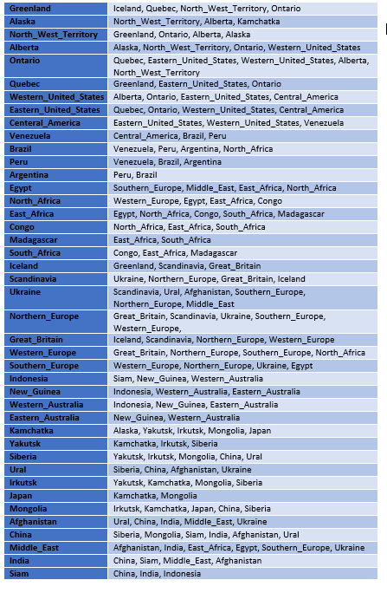**To work out which of the other players regions a player can attack the program will use the adjacency list. The next obvious part of the code which is going to be possibly the most difficult. This is to set up the adjacency list within the program that can be accessed to allow users to complete the attack phase and later on the reinforce phase of their turn. I started with the very basics by creating a table in word of what the adjacency list would look like for each region as is shown below in figure 2.7.**

**The next stage is to then implement this into the program. This will be done through an adjacency list class with an array of linked lists, where each element will be a sting which stores the destination vertex(region) and doesn’t need to include the weight of the edge as if added would automatically be 1 anyway. To do this, an adjacency list constructor method must be made in order to create and store all the linked lists for each of the regions. Then each object of that class for each region must be instantiated (this would be done at the beginning of the code along with creating the region classes) using the constructor method and then the edges (regions) added to all the Region Lists using an add edge method within the initialising function of the gameboard form.**

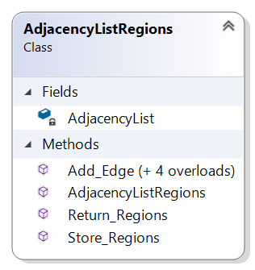**Since each of the 42 regions only have either 2,3,4,5 or 6 nodes to add, I will create these methods within the adjacency list class with the same name. This way they would overload each other depending on how many variables are given. These will all then be added as mentioned in the initial function when the game board form is opened. The class diagram and description are also shown below in figure 2.8 and 2.9.**

Figure 2.7

|  |
| --- |
| Class description for AdjacencyListRegions class |
| String AdjacencyList – represents the adjacency list name |
| Method Add Edge(string region/’s) – Depending on how many regions a player wishes to add will add to the specified linked list |
| Method AdjacencyListRegions – Constructor method to create a new linked list |
| Method Return Regions (ref string)– Adds the regions connected to a specified region list and puts them in a visual format |
| Method Store Regions(ref list)– Adds the regions connected to a specified region and stores them all in a list |

Figure 2.9

**This is a general algorithm for the use of this adjacency list for use in the attacking and reinforce stage assuming each region already has a list of reachable regions that will be pre-set at the beginning of the code. This will add the reachable regions to a separate list that can then be compared later on.**

Figure 2.8

**List = List.CLEAR**

**FOREACH (LinkedList<Country(class)> List IN AdjacencyList(class)) DO**

**FOREACH (Country(class) IN LinkedList<Country(class)>) DO**

**List.ADD Country(class)**

**For the attack phase to work, I would have to split the attack phase into two game states, one for when the player clicks one of their regions to attack from and then one for when the player clicks the opponent’s region to attack. The option to end the players attack phase and begin the reinforce phase should be presented before each attack and even at the beginning before any attack has been made. Once a player has selected a region to attack from, the program should then move to the next game state where it will allow them to attack another players region that it can reach (These will be highlighted green or red if not reachable). This will use the adjacency list to search through the regions reachable regions and then enable the player to attack an adjacent enemy region. This process would then need to be done for the mouse click event.**

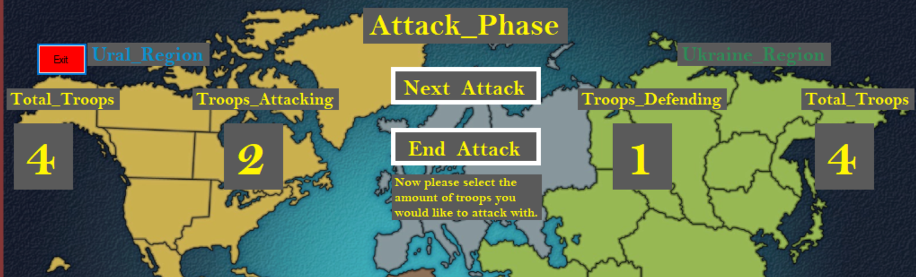**This would use the same conditions for a successful click as the mouse enter event did (An adjacent enemy region can be attacked) and when an enemy region is selected it will change the border to red, so it is clearer to see. It should then immediately start the actual attack. For this, I decided to create a UI for the actual attack phase so it much more visually pleasing and easier to navigate and use during the actual attack (One of my main objectives). This will consist of a few things including Troops in both the regions, number of attacking and defending troops and the dice rolls. When both regions have been selected the region buttons will all be hidden and the UI for the attack will come up on top of the game board looking something like this below.**

Total troops in defending region

Troops attacking/defending

Total troops in attacking region

Player region in their colour

Figure 2.10

**After this was completed, the next thing to program was the player selecting how many troops they want to attack with from that region. The first thing in order to program this would be to work out how many troops they can actually attack with (1 › (troops in region – 1)) and then display these in a drop-down list. Once selected the program would store this number in the troops attacking box then work out how many the defending region can defend with (Max troops in that region) and similarly display this in the troops defending box. After this, the player must then select the number of troops they want to attack with in the actual attack (1 › 3) depending how many they have available. A drop-down list will allow the attacking player to select the troops and then they will be prompted to click the begin attack button.**

**This will then start the calculations for the attack, firstly by working out the random dice rolls for the attacking and defending player, then store them in 2 lists that will get sorted so they are in largest to smallest order. After this, the rolls will then be displayed in the attack text box and the top rolls from each list will be compared and the program, using the logic that the highest role wins and in a draw defender wins, will calculate how many troops each side loses. When this is calculated it will need to make changes to several things including, the total troops for the attack UI, then the troops attacking for both the attacker and defender. Namely if the attacker wins then it needs to take 1 away from the defender’s region, total troops and troops defending. If the defender wins then it needs to take away the same for the attacker. It would then also need to check if the region then had 0 troops in it. If this is the case, then it needs to move the attackers attacking troops into the region and change the occupier so that the attacker is the new occupier of that region and of course exit that attack.**

**However, if the region still has more troops in it, then the player can either click next attack to carry out another attack or click end attack to end attacking that region. If they click to attack again then it will repeat the previous steps for an attack until either the player or defender have no troops left, or the player chooses to end the attack.**

**If the end attack button is clicked, then it will exit that attack. The program will then need to change the border colours back to the occupying player’s colours using the stored colours and prompt the player to either attack again or end the attack phase. After this the whole attack turn will repeat either allowing them to attack again or when the next button has been clicked move onto the reinforce phase of a players turn.**

**I found coding the attack conditions and attacking phase extremely difficult. This was due to the fact that there were many different variables, classes and buttons that had to all be accessed, edited and used all in conjunction. Not to mention all the functions that had to be created and called in order to be able to get it to work. So, when I had all the logic programmed and the attack phase working, I was immensely proud of it.**

* 1. **Reinforce stage-**

**The next and last stage of a player’s turn is the reinforce phase. This is where a player has the opportunity to move troops from one of their occupied regions to another adjacent one to reinforce it. Here is a general algorithm for this part.**

**## the program will use the adjacency list to work out which adjacent territories can be reached by the selected one**

**## the player will select one of their territories**

**IF (units on territory = 0) THEN**

**OUTPUT (“there aren’t enough units on this territory to reinforce another one”)**

**ELSE THEN**

**troops available = units on territory - 1**

**OUTPUT (“How many troops would you like to move? (2 – troops available)”)**

**## player then selects which adjacent territory they would like to move these troops to**

**When it starts the reinforce stage the game state will switch to 5. The conditions for the mouse enter function is that it will highlight a region if it is occupied by the player, connecting to at least 1 other region that they occupy and has 2+ troops in it. While doing this part I will have finished all the mouse enter and mouse click for each of the game states (1-6)for each of the buttons and so would be able to put them all inside one final function and use this for every button enter and click function for each of the 42 buttons.**

**If a player chooses to reinforce, it will allow them to first click a region they occupy that meets the conditions specified above. When they click a region, it will store the selected region in a variable (one for the region and a separate one for the button) and then change to the final game state (6). Using the region they selected, it will highlight green any adjacent region surrounding it using the algorithm mentioned in the attack phase. It will then allow the player to click an adjacent region they occupy to reinforce to. After they have clicked a second region it will then store this is another 2 variables and then create a drop-down list to select the number of troops they want to reinforce with.**

**For this I used a previous combo box but just added an “if game state == 6” statement into it meaning I could use the same combo box for 2 different parts of the program rather than having to create another one. The player could then pick the troops they want to move. The program will then make any changes to the region classes and buttons depending on how many troops are selected to be moved (take away the troops from one region and add them on to the other). After this it will display that the region has been reinforced and prompt the user to click the end turn button to end their turn. When the end turn button is clicked the program will run the next player function to move to the next player. As well as this, it will go back to game state 2, make the troops to play visible and display a prompt to click the begin button to start that players turn.**

**This will then carry on cycling through each player’s turn until the winning condition is met.**

**As previously mentioned there will be 6 game states and each button will have a mouse enter and mouse click function for each game state. Below follows the general algorithms that I intent to implement for each of these functions.**

**Mouse enter function for game state 0,1 & 2**

**This function will simply highlight if game state is 0 buttons with a grey back colour. If the game state is either 1 or 2 it will check if a button is occupied by the player and highlight it in green if it is or red if it isn’t.**

**IF (Game_State = 0) THEN**

**button.BACKCOLOUR = Colour(90, 90, 90)**

**IF (Game_State = 1 OR Game_State = 2) THEN**

**Check_Region_Function(regions)**

**## This will check if a region is occupied by the current player**

**Mouse enter function for game state 3**

**This function will highlight a button green if it has more than 2 troops in it (able to attack) and if it has at least 1 enemy region adjacent to it. If it doesn’t meet these conditions, then it will highlight the button red.**

**IF (Game_State = 3) THEN**

**regionlist.Store_Regions_Function(ref List_Reachable_Regions)**

**##Stores the reachable regions for that region in a separate list**

**bool = FALSE**

**FOREACH (Country(class) Regions in List_Reachable_Regions) DO**

**IF (Regions.Output_Player() != Players_In_Game[Current_Player]) THEN**

**bool = TRUE**

**BREAK**

**IF (Country(class).Output_Troops() >= 2 AND Country(class).Output_Player() Players_In_Game[Current_Player]) AND bool = TRUE) THEN**

**button.BACKCOLOUR = Colour(0, 255, 0)**

**ELSE THEN**

**button.BACKCOLOUR = Colour(255, 0, 0)**

**Mouse enter function for game state 4**

**This function will search through the list of reachable regions for the previously selected. For any buttons that are adjacent and that belong to an enemy player it will highlight them green and for all others it will highlight them in red.**

**IF (Game_State = 4) THEN**

**bool = FLASE**

**FOREACH (Country(class) Regions in List_Reachable_Regions) DO**

**IF (Regions.Output_Name() = country(class).Output_Name() AND Country(class).Output_Player() != Players_In_Game[Current_Player]) THEN**

**bool = TRUE**

**BREAK**

**IF (bool = TRUE) THEN**

**button.BACKCOLOUR = Colour(0, 255, 0)**

**ELSE THEN**

**button.BACKCOLOUR = Colour(255, 0, 0)**

**Mouse enter function for game state 5**

**This function will first search through the selected button and check if it has at least one other button surrounding it that belongs to the enemy player. If it has then it will set bool as true. Then if bool equals true, the button has more than 2 troops in it and belongs to the player it will highlight green. If not, then it will highlight red.**

**IF (Game_State = 5) THEN**

**regionlist.Store_Regions(ref List_Reachable_Regions)**

**bool = FALSE**

**FOREACH (Country(class) Regions in List_Reachable_Regions) DO**

**IF (Regions.Output_Player() == Players_In_Game[Current_Player]) THEN**

**Bool = TRUE**

**BREAK**

**IF (bool = TRUE AND Country(class).Output_Player() = Players_In_Game[Current_Player] AND Country(class).Output_Troops() >= 2) THEN**

**button.BACKCOLOUR = Colour(0, 255, 0)**

**ELSE THEN**

**button.BACKCOLOUR = Colour(255, 0, 0)**

**Mouse enter function for game state 6**

**This function will first search through the list of reachable regions of the previous button that was clicked and set. Then if a region is adjacent and occupied by the player it will highlight green. If not, it will highlight red.**

**IF (Game_State = 6) THEN**

**bool = FALSE**

**FOREACH (Country(class) Regions in List_Reachable_Regions) DO**

**IF (Regions.Output_Name() = country.Output_Name()) THEN**

**bool = TRUE**

**BREAK**

**IF (bool = TRUE AND country.Output_Player() = Players_In_Game[Current_Player]) THEN**

**button.BACKCOLOUR = Colour(0, 255, 0)**

**ELSE THEN**

**button.BACKCOLOUR = Colour(255, 0, 0)**

**Mouse click function for game state 0**

**This function will at the beginning of the turn during the setup phase, if the button hasn’t been occupied, allow a player to occupy a button and then add it to the players list of occupied regions.**

**IF (Game_State = 0 AND (button.Text = "0")) THEN**

**Country(class).Change_Occupier(Players_In_Game[Current_Player])**

**Players_In_Game[Current_Player].Occupied_Regions.ADD(Country(class).Output_Name())**

**Claim_Region(button)**

**Continent.ADD(Country(class))**

**Mouse click function for game state 1**

**This function will first check if the button the player is clicking is occupied by them. If it is, then it will add 1 to the total troops in that region.**

**IF (Game_State = 1) THEN**

**FOREACH (string Selected_Region(Country class) in (Players_In_Game[Current_Player].Occupied_Regions)) DO**

**IF (Selected_Region = (Country(class).Output_Name())) THEN**

**Update_Region(button)**

**Country(class).Add_Troops(1)**

**Mouse click function for game state 2**

**This function will first check if the button the player is clicking is occupied by them. If it is, then it will add 1 to the total troops in that region.**

**IF (Game_State = 2) THEN**

**FOREACH (string Search_region in (Players_In_Game[Current_Player].Occupied_Regions)) DO**

**IF (Search_region = (Country(class).Output_Name())) THEN**

**Update_Region_Fortify(button)**

**Country(class).Add_Troops(1)**

**Mouse click function for game state 3**

**This function will first check that a selected button has at least 1 enemy region adjacent to it. If the button follows this condition, has 2 or more troops and is occupied by the player, then it will change the border colour of the button to green. It will then store the selected button and corresponding region (country class) in variables for use later on.**

**bool = FALSE**

**FOREACH (Country(class) Regions in List_Reachable_Regions) DO**

**IF (Regions.Output_Player() != Players_In_Game[Current_Player]) THEN**

**Bool = TRUE**

**BREAK**

**IF ((Game_State = 3) AND (country(class).Output_Troops() >= 2) AND (country.Output_Player() = Players_In_Game[Current_Player]) AND bool = TRUE) THEN**

**Country_Selected_Attack = country(class)**

**Region_Selected_Attack_Button = button**

**HelpText.Text = ("You have chosen to attack with " + country.Output_Name() + ". Please select the region you would like to attack.")**

**button.BORDERCOLOUR = Colour(0, 255, 0)**

**Game_State = Game_Period.Attack_Player**

**regionlist.Store_Regions(ref List_Reachable_Regions)**

**Attack_button.FORECOLOUR = Colour((Players_In_Game[Current_Player].Output_Colour(0)), (Players_In_Game[Current_Player].Output_Colour(1)), (Players_In_Game[Current_Player].Output_Colour(2)))**

**Mouse click function for game state 4**

**This function will first check if a button is adjacent to the previously selected button using the list of reachable regions list. If a button is adjacent and occupied by an enemy player, the conditions will be met. It should then proceed to store the 2nd selected button and corresponding region in another 2 variables to be used in the actual attack. Finally, it will then load up the attack UI.**

**IF (Game_State = 4) THEN**

**bool = FALSE**

**FOREACH (Country(class) Regions in List_Reachable_Regions)**

**IF (Regions.Output_Name() = country(class).Output_Name() AND country.Output_Player() != Players_In_Game[Current_Player]) THEN**

**bool = TRUE**

**BREAK**

**IF (bool = TRUE) THEN**

**Defend_button.FORECOLOUR = Colour(country.Output_Player().Output_Colour(0), country.Output_Player().Output_Colour(1), country.Output_Player().Output_Colour(2));**

**Country_Selected_Defend = country(class)**

**Region_Selected_Defend_Button = button**

**Button.BORDERCOLOUR = Colour(255, 0, 0)**

**HelpText.Text = ("Attack_Phase - Please refer to the other HelpBox.")**

**Attack_HelpText.Text = ("You have chosen to attack " + Country_Selected_Defend.Output_Name() + " with " + Country_Selected_Attack.Output_Name() + ". Please select the total amount of troops you wish to attack with.")**

**Attack_Region.Text = Country_Selected_Attack.Output_Name()**

**Defend_Region.Text = Country_Selected_Defend.Output_Name()**

**FOREACH (Control form in this.Controls) DO**

**IF ((Convert.ToString(form.Tag)) = "Attack_Phase") THEN**

**form.VISIBLE = TRUE**

**Select_Total_Troops.Items.CLEAR()**

**Total_Troops_Attacking_Number.Text = Country_Selected_Attack.Output_Troops()**

**Total_Troops_Defending_Number.Text = Country_Selected_Defend.Output_Troops()**

**int troops = Country_Selected_Attack.Output_Troops()**

**int count = 2**

**Select_Total_Troops.Items.ADD(1 + " Troop")**

**WHILE (count < troops) DO**

**Select_Total_Troops.Items.ADD(count + " Troops")**

**Count + 1**

**Mouse click function for game state 5**

**This function will first check that the selected button is occupied by a player and has at least one of their buttons adjacent to it. If these conditions are met and the button has 2 or more troops in it, then it will be selected as the button the player wants to reinforce from.**

**IF (Game_State = 5) THEN**

**regionlist.Store_Regions(ref List_Reachable_Regions)**

**bool = FALSE**

**FOREACH (Country(class) Regions in List_Reachable_Regions) DO**

**IF (Regions.Output_Player() == Players_In_Game[Current_Player]) THEN**

**bool = TRUE**

**BREAK**

**IF (bool = TRUE AND country(class).Output_Player() = Players_In_Game[Current_Player] AND country(class).Output_Troops() >= 2) THEN**

**Country_Selected_Reinforce = country(class)**

**Region_Selected_Reinforce_Button = button**

**HelpText.Text = ("You have chosen to reinforce with " + country.Output_Name() + ". Please choose an adjacent region to reinforce.")**

**Game_State = Game_Period.Reinforce_Move**

**Mouse click function for game state 6**

**This function will first check using the list of reachable regions that was worked out in the previous click function if the selected button is adjacent to the previously selected button. If it is adjacent and also is occupied by the player, then it will ask the player how many troops they wish to move. When the player has inputted how many they wish to move it will then calculate how many troops leave one button and how many enter the other.**

**IF (Game_State = 6) THEN**

**Country_Selected_Reinforce_To = country(class)**

**Region_Selected_Reinforce_To_Button = button**

**bool = FALSE**

**FOREACH (Country(class) Regions in List_Reachable_Regions) DO**

**IF (Regions.Output_Name() = country.Output_Name()) THEN**

**bool = TRUE**

**BREAK**

**IF (bool = TRUE AND country.Output_Player() = Players_In_Game[Current_Player]) THEN**

**Select_Total_Troops.Items.CLEAR**

**int count = 1**

**WHILE (count < Country_Selected_Reinforce.Output_Troops()) DO**

**Select_Total_Troops.Items.ADD(count + " Troops")**

**count+ 1**

* 1. **Winning-**

**The method for checking if a player has won will be as a tick timer control that will be ran throughout the duration of the program. The general algorithm for checking if a player has won is as follows below.**

**IF (player eliminated == TRUE) FOR each other player THEN**

**OUTPUT (“well done [player name] you are victorious”)**

**## the program will then store the game details in a file named “high scores” containing the players in the game, who won and in how many turns it took them to won (optional)**

**OUTPUT (“press enter to quit”)**

**## when the player presses enter the program will either exit or return to the menu screen**

**ELSE THEN**

**CONTINUE**

**When a player has met the winning conditions, a message will display on the screen saying that they have won. The program should then need to store the game details in a text file(optional). This will be located at the same location as the rules text file and will have implement a try catch loop on the off chance that the text file can’t be found or alternatively create a new one (optional). Once it has opened the file it will need to store the games information in it including the game winner, all the players, how many turns the game lasted and the date and time it was played (optional). After the win message has displayed for 10 seconds the program will then either quit or go back to the main menu. I decided to try and be able to exit back to the main menu. Firstly, the program would need to initialise all the variables (Occupied regions, Players in game etc) so that they wouldn’t override each other if a new game is started again. While doing this I decided to make a button appear that could be clicked following a prompt on the help text in order to exit back to the main menu. Once clicked this button will then exit back to the start menu and allow a new game to be initiated or the program to be quit.**

# Section 3 – Technical Solution

**My technical solution will again be split up into the different classes and forms contained in the code. These being, the start menu form, the game board form, the player class, the country class and the adjacency list class. It will then at the end contain the screenshots from the working program as well as a table of all functions and variables and what they are used for.**

**(3.1) Start-up menu-**

**Below is the code from the start up menu form and annotated screenshots of the main screen plus help menu. The start menu should allow the user to start a new game, quit or open the help screen.**

public partial class StartMenu : Form

{

public StartMenu()

{

InitializeComponent();

}

private void Form1_Load(object sender, EventArgs e)

{

}

private void NewGame_Click(object sender, EventArgs e)

{

GameBoard form = new GameBoard();

form.Show();

this.Hide();

}

private void Quit_Click(object sender, EventArgs e)

{

Application.Exit();

}

private void Help_Click(object sender, EventArgs e)

{

try

{

string text = File.ReadAllText(@"D:/College/Computer Science/rules.txt");

HelpBox.Text = text;

HelpBoxQuit.Visible = true;

HelpBox.BackColor = SystemColors.Control;

HelpBox.Visible = true;

}

catch

{

HelpBox.Text = ("Help file not found. Please follow the web address - www.hasbro.com/risk/game-rules");

HelpBoxQuit.Visible = true;

HelpBox.BackColor = SystemColors.Control;

HelpBox.Visible = true;

}

}

private void HelpBoxQuit_Click(object sender, EventArgs e)

{

HelpBoxQuit.Visible = false;

HelpBox.Visible = false;

}

}

Figure 3.1

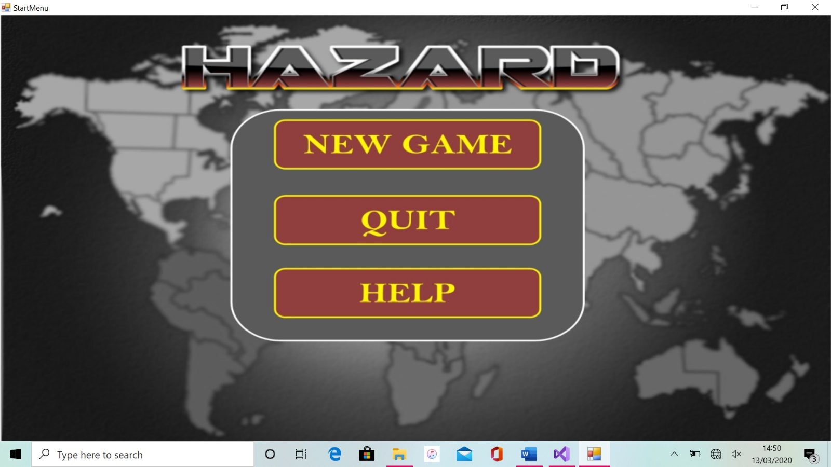

Button NewGame

Button Quit

Button Help

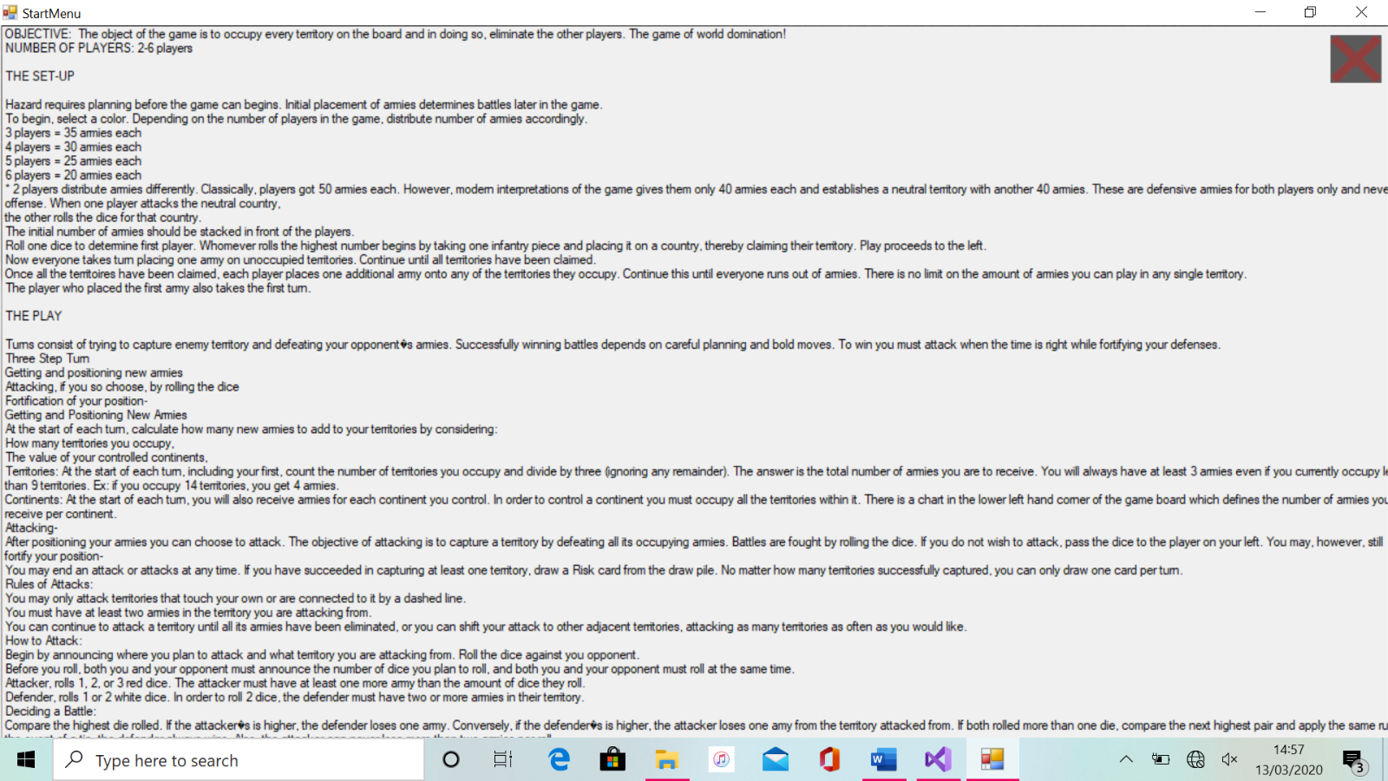

Button HelpBoxQuit

Figure 3.2

**(3.2) Player class-**

**Below is the player class containing the methods to get and set the private attributes.**

public class Player

{

private int Troops_To_Place = 0;

private int[] Player_Colour = new int[3];

private string Player_Name = "";

public List<string> Occupied_Regions = new List<string>();

public Player(string name, int r, int g, int b)

{

Player_Name = name;

Player_Colour[0] = r;

Player_Colour[1] = g;

Player_Colour[2] = b;

}

public string Output_Player_Name()

{

return Player_Name;

}

public int Output_Colour (int colour_position)

{

return Player_Colour[colour_position];

}

public void Add_Region(string region)

{

Occupied_Regions.Append(region);

}

public void Remove_Region(string region)

{

int count = 0;

foreach (string regions in Occupied_Regions)

{

if (regions == region)

{

Occupied_Regions.Remove(r);

}

count++;

}

}

public void Set_Troops (int troops)

{

Troops_To_Place = troops;

}

public void Add_Troops(int troops)

{

Troops_To_Place += troops;

}

public int Output_Troops ()

{

return Troops_To_Place;

}

}

**(3.3) Country class-**

**Below is the country class containing again the methods to get and set the attributes.**

public class Country

{

private string Name = "";

private int Troops = 0;

private Player Occupier;

public Country(String name)

{

Name = name;

Troops = 1;

}

public void Change_Occupier(Player player)

{

Occupier = player;

}

public void Add_Troops(int TroopsToAdd)

{

Troops += TroopsToAdd;

}

public void Remove_Troops(int TroopsToRemove)

{

Troops -= TroopsToRemove;

}

public int Output_Troops()

{

return Troops;

}

public Player Output_Player()

{

return Occupier;

}

public string Output_Name()

{

return Name;

}

}

**(3.4) AdjacencyListRegions class-**

**This is a class that I am particularly proud of as is the implementation of an adjacency list for the regions within the program. This includes the constructor method as well as methods to add differing numbers of edges (regions) using an overload method. Finally, a function to return regions in a list and one to store the regions in a variable.**

public class AdjacencyListRegions

{

public LinkedList<Country>[] AdjacencyList;

public AdjacencyListRegions(int regions)

{

AdjacencyList = new LinkedList<Country>[regions];

for (int count = 0; count < AdjacencyList.Length; count++)

{

AdjacencyList[count] = new LinkedList<Country>();

}

}

//functions for adding regions to the lists

public void Add_Edge(Country Region1, Country Region2)

Add_Edge function is repeated here for but with more inputs

{

int position = 0;

AdjacencyList[position].AddLast(Region1);

position++;

AdjacencyList[position].AddLast(Region2);

}

public void Add_Edge(Country Region1, Country Region2, Country Region3)

{

**As above…**

}

public void Add_Edge(Country Region1, Country Region2, Country Region3, Country Region4)

{

**As above…**

}

public void Add_Edge(Country Region1, Country Region2, Country Region3, Country Region4, Country Region5)

{

**As above…**

}

public void Add_Edge(Country Region1, Country Region2, Country Region3, Country Region4, Country Region5, Country Region6)

{

**As above…**

}

public void Return_Regions(ref string text)

{

int count = 0;

foreach (LinkedList<Country> list in AdjacencyList)

{

text += (" Region [" + count + "] :");

foreach (Country connection in list)

{

text += (connection);

}

count++;

}

}

public void Store_Regions (ref List<Country> list)

{

int count = 0;

list.Clear();

foreach (LinkedList<Country> list_regions in AdjacencyList)

{

foreach (Country connection in list_regions)

{

list.Add(connection);

}

count++;

}

}

}

**(3.5) GameBoard form-**

**Seeing as this form is the biggest section of code, I will split it up with each of the different areas within the form.**

**(3.5.1) Instantiation of variables and class objects -**

**The first area that will follow below is the instantiation of the variables, lists using classes and variables, class objects and public static variables. I have used public static variables as they need to be passed through all the 84 different button functions and to change this to pass them through one by one would require changing the internal workings of the event function structure for the form controls.**

public partial class GameBoard : Form

{

//Creating objects of country class for each region

Country Greenland_Region = new Country("Greenland_Region");

Country Alaska_Region = new Country("Alaska_Region");

Country North_West_Territory_Region = new Country("North_West_Territory_Region");

Country Alberta_Region = new Country("Alberta_Region");

Country Ontario_Region = new Country("Ontario_Region");

Country Quebec_Region = new Country("Quebec_Region");

Country Western_United_States_Region = new Country("Western_United_States_Region");

Country Eastern_United_States_Region = new Country("Eastern_United_States_Region");

Country Central_America_Region = new Country("Central_America_Region");

Country Venezuela_Region = new Country("Venezuela_Region");

Country Brazil_Region = new Country("Brazil_Region");

Country Peru_Region = new Country("Peru_Region");

Country Argentina_Region = new Country("Argentina_Region");

Country Egypt_Region = new Country("Egypt_Region");

Country North_Africa_Region = new Country("North_Africa_Region");

Country East_Africa_Region = new Country("East_Africa_Region");

Country Congo_Region = new Country("Congo_Region");

Country Madagascar_Region = new Country("Madagascar_Region");

Country South_Africa_Region = new Country("South_Africa_Region");

Country Iceland_Region = new Country("Iceland_Region");

**Does this for all 42 regions…**

//Creating linked list for each region

AdjacencyListRegions Greenland_List = new AdjacencyListRegions(4);

AdjacencyListRegions Alaska_List = new AdjacencyListRegions(3);

AdjacencyListRegions North_West_Territory_List = new AdjacencyListRegions(4);

AdjacencyListRegions Alberta_List = new AdjacencyListRegions(4);

AdjacencyListRegions Ontario_List = new AdjacencyListRegions(5);

AdjacencyListRegions Quebec_List = new AdjacencyListRegions(3);

AdjacencyListRegions Western_United_States_List = new AdjacencyListRegions(4);

AdjacencyListRegions Eastern_United_States_List = new AdjacencyListRegions(4);

AdjacencyListRegions Central_America_List = new AdjacencyListRegions(3);

AdjacencyListRegions Venezuela_List = new AdjacencyListRegions(3);

AdjacencyListRegions Brazil_List = new AdjacencyListRegions(4);

AdjacencyListRegions Peru_List = new AdjacencyListRegions(3);

AdjacencyListRegions Argentina_List = new AdjacencyListRegions(2);

AdjacencyListRegions Egypt_List = new AdjacencyListRegions(4);

AdjacencyListRegions North_Africa_List = new AdjacencyListRegions(5);

AdjacencyListRegions East_Africa_List = new AdjacencyListRegions(5);

AdjacencyListRegions Congo_List = new AdjacencyListRegions(3);

AdjacencyListRegions Madagascar_List = new AdjacencyListRegions(2);

AdjacencyListRegions South_Africa_List = new AdjacencyListRegions(3);

AdjacencyListRegions Iceland_List = new AdjacencyListRegions(3);

AdjacencyListRegions Scandinavia_List = new AdjacencyListRegions(4);

AdjacencyListRegions Ukraine_List = new AdjacencyListRegions(6);

AdjacencyListRegions Northern_Europe_List = new AdjacencyListRegions(5);

AdjacencyListRegions Great_Britain_List = new AdjacencyListRegions(4);

AdjacencyListRegions Western_Europe_List = new AdjacencyListRegions(4);

AdjacencyListRegions Southern_Europe_List = new AdjacencyListRegions(4);

AdjacencyListRegions Indonesia_List = new AdjacencyListRegions(3);

**Does this for all 42 regions…**

//creating public static variables that can be accessed from all the functions and 84 button events

public static int Game_State = (Convert.ToInt32(Game_Period.Place_Troops_Initial));

public static int Number_Of_Players = 0, Num_Troops_Attacking = 0, Current_Player = 0, First_Player = 0, Remaining_Countries = 42, count = 0, Players_Complete = 0;

public static List<Player> Players_In_Game = new List<Player>();

public static List<Country> Africa = new List<Country>();

public static List<Country> Asia = new List<Country>();

public static List<Country> Australia = new List<Country>();

public static List<Country> Europe = new List<Country>();

public static List<Country> North_America = new List<Country>();

public static List<Country> South_America = new List<Country>();

public static List<Country> List_Reachable_Regions = new List<Country>();

public static Country Country_Selected_Attack, Country_Selected_Defend, Country_Selected_Reinforce, Country_Selected_Reinforce_To;

public static Button Region_Selected_Defend_Button, Region_Selected_Attack_Button, Region_Selected_Reinforce_Button, Region_Selected_Reinforce_To_Button;

public static List<int> Attacker_Dice_Rolls = new List<int>();

public static List<int> Defender_Dice_Rolls = new List<int>();

public static string Winner = "";

public static Random Random_Number = new Random();

//creating the game period enumerated variable so that it can be used to signify what stage of the game it is currently at

public enum Game_Period { Place_Troops_Initial, Place_Troops_Remaining, Fortify, Attack_Initial, Attack_Player, Reinforce, Reinforce_Move }

**(3.5.2) Setup and mouse click and enter functions -**

**The next part of the program is the main function that will setup the game board each time it is loaded and all the functions for the mouse click and enter for each game state that will be used for all 84 event functions.**

public GameBoard()

{

//hides all the controls that aren't needed, and sets form up for the start of the game

InitializeComponent();

HelpText.Text = ("Please click play when you are ready to start the game.");

Player_Selection_List.Hide();

Player_Name_Enter.Hide();

Advance_Game.Hide();

Static_Label.Hide();

Troops_To_Place.Hide();

Finish_Game.Hide();

Hide_Attack_Phase();

Hide_Buttons();

//adds all the connecting regions to each individual region within the adjacency list region class

Greenland_List.Add_Edge(Iceland_Region, North_West_Territory_Region, Quebec_Region, Ontario_Region);

Alaska_List.Add_Edge(North_West_Territory_Region, Alberta_Region, Kamchatka_Region);

North_West_Territory_List.Add_Edge(Greenland_Region, Ontario_Region, Alberta_Region, Alaska_Region);

Alberta_List.Add_Edge(Alaska_Region, North_West_Territory_Region, Ontario_Region, Western_United_States_Region);

Ontario_List.Add_Edge(Quebec_Region, Eastern_United_States_Region, Western_United_States_Region, Alberta_Region, North_West_Territory_Region);

Quebec_List.Add_Edge(Greenland_Region, Eastern_United_States_Region, Ontario_Region);

Western_United_States_List.Add_Edge(Alberta_Region, Ontario_Region, Eastern_United_States_Region, Central_America_Region);

Eastern_United_States_List.Add_Edge(Quebec_Region, Ontario_Region, Western_United_States_Region, Central_America_Region);

Central_America_List.Add_Edge(Eastern_United_States_Region, Western_United_States_Region, Venezuela_Region);

Venezuela_List.Add_Edge(Central_America_Region, Brazil_Region, Peru_Region);

Brazil_List.Add_Edge(Venezuela_Region, Peru_Region, Argentina_Region, North_Africa_Region);

Peru_List.Add_Edge(Venezuela_Region, Brazil_Region, Argentina_Region);

Argentina_List.Add_Edge(Peru_Region, Brazil_Region);

Egypt_List.Add_Edge(Southern_Europe_Region, Middle_East_Region, East_Africa_Region, North_Africa_Region);

North_Africa_List.Add_Edge(Western_Europe_Region, Egypt_Region, East_Africa_Region, Congo_Region, Brazil_Region);

East_Africa_List.Add_Edge(Egypt_Region, North_Africa_Region, Congo_Region, South_Africa_Region, Madagascar_Region);

Congo_List.Add_Edge(North_Africa_Region, East_Africa_Region, South_Africa_Region);

Madagascar_List.Add_Edge(East_Africa_Region, South_Africa_Region);

South_Africa_List.Add_Edge(Congo_Region, East_Africa_Region, Madagascar_Region);

Iceland_List.Add_Edge(Greenland_Region, Scandinavia_Region, Great_Britain_Region);

**Does this for all 42 regions…**

private void Click_AllGameState(Country country, Button region, AdjacencyListRegions regionlist, List<Country> continent)

{

Click_GameState0(country, region, continent);

Click_GameState1(country, region);

Click_GameState2(country, region);

Click_GameState3(country, region, regionlist);

Click_GameState4(country, region, regionlist);

Click_GameState5(country, region, regionlist);

Click_GameState6(country, region);

}

private void Click_GameState6(Country, Button region)

{

if (Game_State == 6)

{

Country_Selected_Reinforce_To = country;

Region_Selected_Reinforce_To_Button = region;

bool check = false;

foreach (Country Regions in List_Reachable_Regions)

{

if (Regions.Output_Name() == country.Output_Name())

{

check = true;

break;

}

}

if (check == true && country.Output_Player() == Players_In_Game[Current_Player])

{

Select_Total_Troops.Show();

Select_Total_Troops.Items.Clear();

Select_Total_Troops.DropDownHeight = 200;

int count = 1;

while (count < Country_Selected_Reinforce.Output_Troops())

{

Select_Total_Troops.Items.Add(count + " Troops");

count++;

}

Hide_Buttons();

}

}

}

private void Click_GameState5(Country, Button region, AdjacencyListRegions regionlist)

{

if (Game_State == 5)

{

regionlist.Store_Regions(ref List_Reachable_Regions);

bool check = false;

foreach (Country Regions in List_Reachable_Regions)

{

if (Regions.Output_Player() == Players_In_Game[Current_Player])

{

check = true;

break;

}

}

if (check == true && country.Output_Player() == Players_In_Game[Current_Player] && country.Output_Troops() >= 2)

{

Country_Selected_Reinforce = country;

Region_Selected_Reinforce_Button = region;

HelpText.Text = ("You have chosen to reinforce with " + country.Output_Name() + ". Please choose an adjacent region to reinforce.");

Game_State = Convert.ToInt32(Game_Period.Reinforce_Move);

Advance_Game.Hide();

}

}

}

private void Click_GameState4(Country country, Button region, AdjacencyListRegions regionlist)

{

if (Game_State == 4)

{

bool flag = false;

foreach (Country Regions in List_Reachable_Regions)

{

if (Regions.Output_Name() == country.Output_Name() && country.Output_Player() != Players_In_Game[Current_Player])

{

flag = true;

break;

}

}

if (flag == true)

{

Defend_Region.ForeColor = Color.FromArgb(country.Output_Player().Output_Colour(0), country.Output_Player().Output_Colour(1), country.Output_Player().Output_Colour(2));

Country_Selected_Defend = country;

Region_Selected_Defend_Button = region;

region.FlatAppearance.BorderColor = Color.FromArgb(255, 0, 0);

HelpText.Text = ("Attack_Phase - Please refer to the other HelpBox.");

Attack_HelpText.Text = ("You have chosen to attack " + Country_Selected_Defend.Output_Name() + " with " + Country_Selected_Attack.Output_Name() + ". Please select the total amount of troops you wish to attack with.");

Attack_Region.Text = Country_Selected_Attack.Output_Name();

Defend_Region.Text = Country_Selected_Defend.Output_Name();

Hide_Buttons();

foreach (Control form in this.Controls)

{

if ((Convert.ToString(form.Tag)) == "Attack_Phase")

{

form.Visible = true;

}

}

Select_Total_Troops.Items.Clear();

Total_Troops_Attacking_Number.Text = (Convert.ToString(Country_Selected_Attack.Output_Troops()));

Total_Troops_Defending_Number.Text = (Convert.ToString(Country_Selected_Defend.Output_Troops()));

int troops = Country_Selected_Attack.Output_Troops();

int count = 2;

Select_Total_Troops.Items.Add(1 + " Troop");

while (count < troops)

{

Select_Total_Troops.Items.Add(count + " Troops");

count++;

}

Next_Attack.Enabled = false;

End_Attack.Enabled = false;

Select_Troops_To_Attack.Hide();

Select_Total_Troops.DropDownHeight = 200;

}

}

}

private void Click_GameState3(Country country, Button region, AdjacencyListRegions regionlist)

{

bool check = false;

foreach (Country Regions in List_Reachable_Regions)

{

if (Regions.Output_Player() != Players_In_Game[Current_Player])

{

check = true;

break;

}

}

if ((Game_State == 3) && (country.Output_Troops() >= 2) && (country.Output_Player() == Players_In_Game[Current_Player]) && check == true)

{

Country_Selected_Attack = country;

Region_Selected_Attack_Button = region;

HelpText.Text = ("You have chosen to attack with " + country.Output_Name() + ". Please select the region you would like to attack.");

Advance_Game.Hide();

region.FlatAppearance.BorderColor = Color.FromArgb(0, 255, 0);

Game_State = Convert.ToInt32(Game_Period.Attack_Player);

regionlist.Store_Regions(ref List_Reachable_Regions);

Attack_Region.ForeColor = Color.FromArgb((Players_In_Game[Current_Player].Output_Colour(0)), (Players_In_Game[Current_Player].Output_Colour(1)), (Players_In_Game[Current_Player].Output_Colour(2)));

}

}

private void Click_GameState2(Country country, Button region)

{

if (Game_State == 2)

{

foreach (string Search_region in (Players_In_Game[Current_Player].Occupied_Regions))

{

if (Search_region == (country.Output_Name()))

{

Update_Region_Fortify(region);

country.Add_Troops(1);

}

}

}

}

private void Click_GameState1(Country country, Button region)

{

if (Game_State == 1)

{

foreach (string Selected_Region in (Players_In_Game[Current_Player].Occupied_Regions))

{

if (Selected_Region == (country.Output_Name()))

{

Update_Region(region);

country.Add_Troops(1);

}

}

}

}

private void Click_GameState0(Country country, Button region, List<Country> Continent)

{

if (Game_State == 0 && (region.Text == "0"))

{

country.Change_Occupier(Players_In_Game[Current_Player]);

Players_In_Game[Current_Player].Occupied_Regions.Add(country.Output_Name());

Claim_Region(region);

Continent.Add(country);

}

}

//functions for Mouse enter events for differing game states

private void MouseEnter_AllGameState(Button region, Country country, AdjacencyListRegions regionlist)

{

MouseEnter_GameState012(region);

MouseEnter_GameState3(region, country, regionlist);

MouseEnter_GameState4(region, country);

MouseEnter_GameState5(region, country, regionlist);

MouseEnter_GameState6(region, country);

}

private void MouseEnter_GameState6(Button region, Country country)

{

if (Game_State == 6)

{

bool check = false;

foreach (Country Regions in List_Reachable_Regions)

{

if (Regions.Output_Name() == country.Output_Name())

{

check = true;

break;

}

}

if (check == true && country.Output_Player() == Players_In_Game[Current_Player])

{

region.BackColor = Color.FromArgb(1, 0, 255, 0);

}

else

{

region.BackColor = Color.FromArgb(1, 255, 0, 0);

}

}

}

private void MouseEnter_GameState5(Button region, Country country, AdjacencyListRegions regionlist)

{

if (Game_State == 5)

{

regionlist.Store_Regions(ref List_Reachable_Regions);

bool check = false;

foreach (Country Regions in List_Reachable_Regions)

{

if (Regions.Output_Player() == Players_In_Game[Current_Player])

{

check = true;

break;

}

}

if (check == true && country.Output_Player() == Players_In_Game[Current_Player] && country.Output_Troops() >= 2)

{

region.BackColor = Color.FromArgb(1, 0, 255, 0);

}

else

{

region.BackColor = Color.FromArgb(1, 255, 0, 0);

}

}

}

private void MouseEnter_GameState4(Button region, Country country)

{

if (Game_State == 4)

{

bool check = false;

foreach (Country Regions in List_Reachable_Regions)

{

if (Regions.Output_Name() == country.Output_Name() && country.Output_Player() != Players_In_Game[Current_Player])

{

check = true;

break;

}

}

if (check == true)

{

region.BackColor = Color.FromArgb(1, 0, 255, 0);

}

else

{

region.BackColor = Color.FromArgb(1, 255, 0, 0);

}

}

}

private void MouseEnter_GameState3(Button region, Country country, AdjacencyListRegions regionlist)

{

if (Game_State == 3)

{

regionlist.Store_Regions(ref List_Reachable_Regions);

bool check = false;

foreach (Country Regions in List_Reachable_Regions)

{

if (Regions.Output_Player() != Players_In_Game[Current_Player])

{

check = true;

break;

}

}

if ((country.Output_Troops() >= 2) && (country.Output_Player() == Players_In_Game[Current_Player]) && check == true)

{

region.BackColor = Color.FromArgb(1, 0, 255, 0);

}

else

{

region.BackColor = Color.FromArgb(1, 255, 0, 0);

}

}

}

private void MouseEnter_GameState012(Button regions)

{

if (Game_State == 0)

{

regions.BackColor = Color.FromArgb(1, 90, 90, 90);

}

if (Game_State == 1 || Game_State == 2)

{

Check_Region(regions);

}

}

**(3.5.3) Repeated and specific task functions -**

**The next section of this form contains all the functions that are used for repeated and specific tasks throughout the program not including the event functions for controls.**

// general functions for repeated tasks

private void Hide_Attack_Phase()

{

foreach (Control form in this.Controls)

{

if ((Convert.ToString(form.Tag)) == "Attack_Phase")

{

form.Visible = false;

}

}

//function hides all form controls with the tag "Attack_Phase"

}

private void Disable_Buttons()

{

foreach (Control form in this.Controls)

{

if ((Convert.ToString(form.Tag)) == "Country")

{

form.Enabled = false;

}

}

//function disables all form controls with the tag "Country"

}

private void Enable_Buttons()

{

foreach (Control form in this.Controls)

{

if ((Convert.ToString(form.Tag)) == "Country")

{

form.Enabled = true;

}

}

//function enables all form controls with the tag "Country"

}

private void Show_Buttons()

{

foreach (Control form in this.Controls)

{

if ((Convert.ToString(form.Tag)) == "Country")

{

form.Show();

}

}

//function shows all form controls with the tag "Country"

}

private void Hide_Buttons()

{

foreach (Control form in this.Controls)

{

if ((Convert.ToString(form.Tag)) == "Country")

{

form.Hide();

}

}

//function hides all form controls with the tag "Country"

}

private void Check_Occupier(List<Country> continent, int troops)

{

bool flag = false;

foreach (Country country in continent)

{

if (country.Output_Player() == (Players_In_Game[Current_Player]))

{

flag = true;

}

else

{

flag = false;

break;

}

}

if (flag == true)

{

Players_In_Game[Current_Player].Add_Troops(troops);

}

//function checks if a player occupies all regions within a continent (list of country class)

}

private void Check_Troops_Remaining_Fortify()

{

Troops_To_Place.Text = (Convert.ToString(Players_In_Game[Current_Player].Output_Troops()));

if ((Players_In_Game[Current_Player].Output_Troops()) == 0)

{

Advance_Game.Show();

Disable_Buttons();

Troops_To_Place.Hide();

HelpText.Text = "You have now fortified your regions. Please click next to begin your attack phase.";

}

//function checks if player has placed all their troops

}

private void Update_Region_Fortify(Button region)

{

region.Text = (Convert.ToString(Convert.ToInt32(region.Text) + 1));

Players_In_Game[Current_Player].Set_Troops(Players_In_Game[Current_Player].Output_Troops() - 1);

Check_Troops_Remaining_Fortify();

//function updates variables when a region is fortified

}

private void Update_Region(Button region)

{

region.Text = (Convert.ToString(Convert.ToInt32(region.Text) + 1));

Players_In_Game[Current_Player].Set_Troops(Players_In_Game[Current_Player].Output_Troops() - 1);

Check_Troops_Remaining();

//function updates region when placing troops at the beginning

}

private void Set_Troops(int troops, int playernum)

{

int count = 0;

while (count != playernum)

{

Players_In_Game[count].Set_Troops(troops);

count++;

}

//function sets troops for player

}

private void Check_Region(Button regions)

{

foreach (string region in (Players_In_Game[Current_Player].Occupied_Regions))

{

if (region == ((regions.Name) + "_Region"))

{

regions.BackColor = Color.FromArgb(1, 0, 255, 0);

break;

}

else

{

regions.BackColor = Color.FromArgb(1, 255, 0, 0);

}

}

//function checks if a region is occupied by a player and if it is changing the back colour to green

}

private void Claim_Region(Button region)

{

region.FlatAppearance.BorderColor = Color.FromArgb((Players_In_Game[Current_Player]).Output_Colour(0), (Players_In_Game[Current_Player]).Output_Colour(1), (Players_In_Game[Current_Player]).Output_Colour(2));

region.Text = Convert.ToString(Convert.ToInt32(region.Text) + 1);

Remaining_Countries--;

Players_In_Game[Current_Player].Set_Troops(Players_In_Game[Current_Player].Output_Troops() - 1);

Next_Player();

//function will change the necessary variables when a player occupies a region for the first time

}

private void Next_Player()

{

if (Current_Player == (Number_Of_Players - 1))

{

Current_Player = 0;

}

else

{

Current_Player++;

}

PlayerTurn.Text = (Convert.ToString(Players_In_Game[Current_Player].Output_Player_Name()));

PlayerTurn.ForeColor = Color.FromArgb((Players_In_Game[Current_Player].Output_Colour(0)), (Players_In_Game[Current_Player].Output_Colour(1)), (Players_In_Game[Current_Player].Output_Colour(2)));

Troops_To_Place.Text = (Convert.ToString(Players_In_Game[Current_Player].Output_Troops()));

//function will move to the next player and change any necessary variables

}

private void Check_Troops_Remaining()

{

Troops_To_Place.Text = (Convert.ToString(Players_In_Game[Current_Player].Output_Troops()));

if ((Players_In_Game[Current_Player].Output_Troops()) == 0)

{

Next_Player();

}

//function will check how many troops are remaining for a player to place

}

private void Comparing_Dice_Rolls(int dice, ref string winner)

{

if (Attacker_Dice_Rolls[dice] > Defender_Dice_Rolls[dice])

{

winner = "Attacker";

}

else if (Attacker_Dice_Rolls[dice] > Defender_Dice_Rolls[dice])

{

winner = "Defender";

}

else

{

winner = "Defender";

}

//function when given the dice rolls and passing variable winner by reference, will calculate the winner and pass it in reference

}

private void Check_Attack_Win()

{

if (Troops_Defending_Number.Text == "0")

//if defender loses all troops

{

Players_In_Game[Current_Player].Occupied_Regions.Add(Country_Selected_Defend.Output_Name());

Country_Selected_Defend.Output_Player().Occupied_Regions.Remove(Country_Selected_Defend.Output_Name());

Country_Selected_Defend.Change_Occupier(Players_In_Game[Current_Player]);

Country_Selected_Defend.Add_Troops(Convert.ToInt32(Troops_Attacking_Number.Text));

Region_Selected_Defend_Button.Text = Convert.ToString(Country_Selected_Defend.Output_Troops());

Country_Selected_Attack.Remove_Troops(Convert.ToInt32(Troops_Attacking_Number.Text));

Region_Selected_Attack_Button.Text = Convert.ToString(Country_Selected_Attack.Output_Troops());

Region_Selected_Defend_Button.FlatAppearance.BorderColor = Color.FromArgb((Players_In_Game[Current_Player]).Output_Colour(0), (Players_In_Game[Current_Player]).Output_Colour(1), (Players_In_Game[Current_Player]).Output_Colour(2));

Hide_Attack_Phase();

Show_Buttons();

HelpText.Text = ("You have successfully defeated this region and you now occupy it. Please either click another region to attack from or click next to end your attack phase.");

Game_State = (Convert.ToInt32(Game_Period.Attack_Initial));

Region_Selected_Attack_Button.FlatAppearance.BorderColor = Color.FromArgb((Players_In_Game[Current_Player]).Output_Colour(0), (Players_In_Game[Current_Player]).Output_Colour(1), (Players_In_Game[Current_Player]).Output_Colour(2));

Advance_Game.Show();

Troops_Attacking_Number.Text = ("-");

Troops_Defending_Number.Text = ("-");

//function will move the attacking player's troops into that region and occupy it

}

else if (Troops_Attacking_Number.Text == "0")

//if attacker loses all troops

{

Hide_Attack_Phase();

Show_Buttons();

Country_Selected_Attack.Remove_Troops(Country_Selected_Attack.Output_Troops());

Country_Selected_Attack.Add_Troops(Convert.ToInt32(Total_Troops_Attacking_Number.Text));

HelpText.Text = ("Your attacking troops have been defeated. Please either click another region to attack from or click next to end your attack phase.");

Game_State = (Convert.ToInt32(Game_Period.Attack_Initial));

Advance_Game.Show();

Region_Selected_Attack_Button.Text = Total_Troops_Attacking_Number.Text;

Region_Selected_Defend_Button.Text = Total_Troops_Defending_Number.Text;

Region_Selected_Attack_Button.FlatAppearance.BorderColor = Color.FromArgb((Players_In_Game[Current_Player].Output_Colour(0)), (Players_In_Game[Current_Player].Output_Colour(1)), (Players_In_Game[Current_Player].Output_Colour(2)));

Region_Selected_Defend_Button.FlatAppearance.BorderColor = Color.FromArgb((Country_Selected_Defend.Output_Player().Output_Colour(0)), (Country_Selected_Defend.Output_Player().Output_Colour(1)), (Country_Selected_Defend.Output_Player().Output_Colour(2)));

Troops_Attacking_Number.Text = ("-");

Troops_Defending_Number.Text = ("-");

//function will end attack and remove necessary troops from both regions

}

}

private void Attack_Update(string winner)

{

if (winner == "Attacker")

{

Country_Selected_Defend.Remove_Troops(1);

Troops_Defending_Number.Text = Convert.ToString(Convert.ToInt32(Troops_Defending_Number.Text) - 1);

Total_Troops_Defending_Number.Text = Convert.ToString(Convert.ToInt32(Total_Troops_Defending_Number.Text) - 1);

}

else

{

Country_Selected_Attack.Remove_Troops(1);

Troops_Attacking_Number.Text = Convert.ToString(Convert.ToInt32(Troops_Attacking_Number.Text) - 1);

Total_Troops_Attacking_Number.Text = Convert.ToString(Convert.ToInt32(Total_Troops_Attacking_Number.Text) - 1);

}

//function will check if the winner is the attack or not. If it is, it will remove 1 troop from the defending region and vice versa

}

private void Attacker_Dice_Roll_3()

{

int Attack_Dice1 = Random_Number.Next(1, 7);

int Attack_Dice2 = Random_Number.Next(1, 7);

int Attack_Dice3 = Random_Number.Next(1, 7);

Attacker_Dice_Rolls.Add(Attack_Dice1);

Attacker_Dice_Rolls.Add(Attack_Dice2);

Attacker_Dice_Rolls.Add(Attack_Dice3);

Attacker_Dice_Rolls.Sort();

Attacker_Dice_Rolls.Reverse();

Attack_HelpText.Text += Convert.ToString(Attacker_Dice_Rolls[0]);

Attack_HelpText.Text += Convert.ToString(Attacker_Dice_Rolls[1]);

Attack_HelpText.Text += Convert.ToString(Attacker_Dice_Rolls[2]);

//function will roll 3 random dice for the attacker and store them in a list

}

private void Attacker_Dice_Roll_1()

{

int Attack_Dice1 = Random_Number.Next(1, 7);

Attacker_Dice_Rolls.Add(Attack_Dice1);

Attacker_Dice_Rolls.Sort();

Attacker_Dice_Rolls.Reverse();

Attack_HelpText.Text += Convert.ToString(Attacker_Dice_Rolls[0]);

//function will roll 1 random die for the attacker and store it in a list

}

private void Defender_Dice_Roll_2()

{

int Defend_Dice1 = Random_Number.Next(1, 7);

int Defend_Dice2 = Random_Number.Next(1, 7);

Defender_Dice_Rolls.Add(Defend_Dice1);

Defender_Dice_Rolls.Add(Defend_Dice2);

Defender_Dice_Rolls.Sort();

Defender_Dice_Rolls.Reverse();

Attack_HelpText.Text += (". The defender rolled: ") + Convert.ToString(Defender_Dice_Rolls[0]);

Attack_HelpText.Text += Convert.ToString(Defender_Dice_Rolls[1]);

//function will roll 3 random dice for the defender and store them in a list

}

private void Defender_Dice_Roll_1()

{

int Defend_Dice1 = Random_Number.Next(1, 7);

Defender_Dice_Rolls.Add(Defend_Dice1);

Attack_HelpText.Text += (" The defender rolled: ") + Convert.ToString(Defender_Dice_Rolls[0]);

//function will roll 1 random die for the defender and store it in a list

}

private void Compare_2_Dice()

{

Comparing_Dice_Rolls(0, ref Winner);

Attack_Update(Winner);

Comparing_Dice_Rolls(1, ref Winner);

Attack_Update(Winner);

Check_Attack_Win();

//compares 2 dice rolls

}

private void Compare_1_Dice()

{

Comparing_Dice_Rolls(0, ref Winner);

Attack_Update(Winner);

Check_Attack_Win();

//compares 2 dice rolls

}

**(3.5.4) Functions for form control events -**

**The next section of this form contains the event functions for the form controls excluding the mouse click and enter function foe the region buttons.**

//functions for events for form controls

private void End_Attack_Click(object sender, EventArgs e)

{

Hide_Attack_Phase();

Show_Buttons();

HelpText.Text = ("You have withdrawn your troops. Please either click another region to attack from or click next to end your attack phase.");

Game_State = (Convert.ToInt32(Game_Period.Attack_Initial));

Advance_Game.Show();

Region_Selected_Attack_Button.Text = Total_Troops_Attacking_Number.Text;

Region_Selected_Defend_Button.Text = Total_Troops_Defending_Number.Text;

Region_Selected_Attack_Button.FlatAppearance.BorderColor = Color.FromArgb((Players_In_Game[Current_Player].Output_Colour(0)), (Players_In_Game[Current_Player].Output_Colour(1)), (Players_In_Game[Current_Player].Output_Colour(2)));

Region_Selected_Defend_Button.FlatAppearance.BorderColor = Color.FromArgb((Country_Selected_Defend.Output_Player().Output_Colour(0)), (Country_Selected_Defend.Output_Player().Output_Colour(1)), (Country_Selected_Defend.Output_Player().Output_Colour(2)));

Troops_Attacking_Number.Text = ("-");

Troops_Defending_Number.Text = ("-");

}

private void Finish_Game_Click(object sender, EventArgs e)

{

Finish_Game.Hide();

Game_State = Convert.ToInt32(Game_Period.Place_Troops_Initial);

foreach (Player players in Players_In_Game)

{

players.Occupied_Regions.Clear();

}

Players_In_Game.Clear();

StartMenu form = new StartMenu();

form.Show();

this.Hide();

}

private void Play_Button_Click(object sender, EventArgs e)

{

Play_Button.Hide();

Play_Button.Enabled = false;

Player_Selection_List.Show();

HelpText.Text = ("Please select the number of players you wish to play the game with.");

}

private void Player_Selection_List_SelectedIndexChanged(object sender, EventArgs e)

{

Player_Selection_List.Hide();

Player_Selection_List.Enabled = false;

HelpText.Text = ("You have chosen to play with " + (Convert.ToString(Player_Selection_List.SelectedItem)) + " Please enter your username's. Once you have entered your name press the space key to enter.");

Number_Of_Players = Convert.ToInt32(Convert.ToString(Player_Selection_List.SelectedItem).Substring(0, 1));

Player_Name_Enter.Show();

}

private void Player_Name_Enter_TextChanged(object sender, EventArgs e)

{

foreach (char s in (Convert.ToString(Player_Name_Enter.Text)))

{

if (s == ' ')

{

string PlayerName = Convert.ToString(Player_Name_Enter.Text);

if (Player1_Name.Text == "Player1")

{

Player1_Name.Text = PlayerName;

Player_Name_Enter.Text = String.Empty;

Player Player1 = new Player(PlayerName, 255, 246, 4);

Players_In_Game.Add(Player1);

}

else if (Player2_Name.Text == "Player2")

{

Player2_Name.Text = PlayerName;

Player_Name_Enter.Text = String.Empty;

Player Player2 = new Player(PlayerName, 0, 0, 0);

Players_In_Game.Add(Player2);

}

else if (Player3_Name.Text == "Player3")

{

Player3_Name.Text = PlayerName;

Player_Name_Enter.Text = String.Empty;

Player Player3 = new Player(PlayerName, 8, 146, 208);

Players_In_Game.Add(Player3);

}

else if (Player4_Name.Text == "Player4")

{

Player4_Name.Text = PlayerName;

Player_Name_Enter.Text = String.Empty;

Player Player4 = new Player(PlayerName, 46, 139, 87);

Players_In_Game.Add(Player4);

}

else if (Player5_Name.Text == "Player5")

{

Player5_Name.Text = PlayerName;

Player_Name_Enter.Text = String.Empty;

Player Player5 = new Player(PlayerName, 255, 105, 180);

Players_In_Game.Add(Player5);

}

else if (Player6_Name.Text == "Player6")

{

Player6_Name.Text = PlayerName;

Player_Name_Enter.Text = String.Empty;

Player Player6 = new Player(PlayerName, 255, 36, 0);

Players_In_Game.Add(Player6);

}

count++;

}

if (count == (Number_Of_Players))

{

HelpText.Text = "You have now entered all the usernames. To begin placing your initial troops please click begin.";

Player_Name_Enter.Hide();

Player_Name_Enter.Enabled = false;

Advance_Game.Show();

if (Player3_Name.Text == "Player3")

{

Set_Troops(40, 2);

Player3_Name.Hide();

Player4_Name.Hide();

Player5_Name.Hide();

Player6_Name.Hide();

}

else if (Player4_Name.Text == "Player4")

{

Set_Troops(35, 3);

Player4_Name.Hide();

Player5_Name.Hide();

Player6_Name.Hide();

}

else if (Player5_Name.Text == "Player5")

{

Set_Troops(30, 4);

Player5_Name.Hide();

Player6_Name.Hide();

}

else if (Player6_Name.Text == "Player6")

{

Set_Troops(25, 5);

Player6_Name.Hide();

}

else

{

Set_Troops(20, 6);

}

}

}

}

private void Place_Troops_Initial_Tick(object sender, EventArgs e)

{

if (Remaining_Countries == 0)

{

HelpText.Text = ("All the regions have been occupied. Please press the next button to begin to place your remaining troops on your regions.");

Place_Troops_Initial.Enabled = false;

Disable_Buttons();

Game_State = (Convert.ToInt32(Game_Period.Place_Troops_Remaining));

Advance_Game.Show();

Advance_Game.Text = ("Next");

}

}

private void Select_Troops_SelectedIndexChanged(object sender, EventArgs e)

{

Select_Total_Troops.Hide();

if (Game_State == 6)

{

Country_Selected_Reinforce.Remove_Troops(Select_Total_Troops.SelectedIndex + 1);

Country_Selected_Reinforce_To.Add_Troops(Select_Total_Troops.SelectedIndex + 1);

Region_Selected_Reinforce_Button.Text = (Convert.ToString(Country_Selected_Reinforce.Output_Troops()));

Region_Selected_Reinforce_To_Button.Text = (Convert.ToString(Country_Selected_Reinforce_To.Output_Troops()));

Show_Buttons();

HelpText.Text = (Country_Selected_Reinforce_To.Output_Name() + " has been reinforced. Please click next to end your turn.");

Advance_Game.Show();

Disable_Buttons();

}

else

{

Troops_Attacking_Number.Text = Convert.ToString(Select_Total_Troops.SelectedIndex + 1);

if (Country_Selected_Defend.Output_Troops() < (Convert.ToInt32(Troops_Attacking_Number.Text) - 1))

{

Troops_Defending_Number.Text = Convert.ToString(Country_Selected_Defend.Output_Troops());

}

else

{

Troops_Defending_Number.Text = Convert.ToString(Country_Selected_Defend.Output_Troops());

}

Attack_HelpText.Text = ("Now please select the amount of troops you would like to attack with.");

Select_Troops_To_Attack.Show();

Select_Troops_To_Attack.Items.Clear();

if ((Convert.ToInt32(Troops_Attacking_Number.Text)) >= 3)

{

Select_Troops_To_Attack.Items.Add(1 + " Troop");

Select_Troops_To_Attack.Items.Add(2 + " Troops");

Select_Troops_To_Attack.Items.Add(3 + " Troops");

Num_Troops_Attacking = 3;

}

else if ((Convert.ToInt32(Troops_Attacking_Number.Text)) >= 2)

{

Select_Troops_To_Attack.Items.Add(1 + " Troop");

Select_Troops_To_Attack.Items.Add(2 + " Troops");

Num_Troops_Attacking = 2;

}

else

{

Select_Troops_To_Attack.Items.Add(1 + " Troop");

Num_Troops_Attacking = 1;

}

}

}

private void Check_Win_Tick(object sender, EventArgs e)

{

if (Game_State != 0 || Game_State != 1)

{

count = 0;

while (count < Players_In_Game.Count())

{

if (Players_In_Game[count].Occupied_Regions.Count == 0)

{

Players_In_Game.Remove(Players_In_Game[count]);

}

count++;

}

}

if ((player.Occupied_Regions.Count) == 42)

{

Check_Win.Stop();

Win_Text.Text = (player.Output_Player_Name() + "Has won the game! Well done");

Disable_Buttons();

Advance_Game.Enabled = false;

try

{

Win_Text.Text += (". Game information has been saved to a file.");

string Game_Information = File.ReadAllText(@"D:/College/Computer Science/Game Information.txt");

Game_Information += ("\n\nWinner: " + player.Output_Player_Name() + "\nPlayers in game:\n");

foreach (Player players in Players_In_Game)

{

Game_Information += (players.Output_Player_Name() + "\n");

}

Game_Information += ("This game lasted " + Turn.Text + " turns\n");

Game_Information += ("This game was played at: " + Convert.ToString(DateTime.Now));

File.WriteAllText(@"D:/College/Computer Science/Game Information.txt", Game_Information);

}

catch

{

Win_Text.Text += (". ## FILE NOT FOUND ##");

}

HelpText.Text = ("Please click Finish Game to exit back to the start menu.");

Finish_Game.Show();

}

}

}

private void Place_Remaining_Troops_Tick(object sender, EventArgs e)

{

if (Players_Complete == (Players_In_Game.Count))

{

Place_Remaining_Troops.Enabled = false;

HelpText.Text = ("All players have placed the remainder of their troops. Please click the begin turn button to begin " + (Convert.ToString(Players_In_Game[Current_Player].Output_Player_Name()) + "'s turn."));

Game_State = (Convert.ToInt32(Game_Period.Fortify));

Advance_Game.Text = ("Begin Turn");

Advance_Game.Show();

Current_Player = First_Player;

PlayerTurn.Text = (Convert.ToString(Players_In_Game[Current_Player].Output_Player_Name()));

PlayerTurn.ForeColor = Color.FromArgb((Players_In_Game[Current_Player].Output_Colour(0)), (Players_In_Game[Current_Player].Output_Colour(1)), (Players_In_Game[Current_Player].Output_Colour(2)));

foreach (Control form in this.Controls)

{

if ((Convert.ToString(form.Tag)) == "Country")

{

form.Enabled = false;

}

}

}

else

{

if ((Players_In_Game[Current_Player].Output_Troops()) == 0)

{

Players_Complete++;

Next_Player();

}

}

}

private void Next_Attack_Click(object sender, EventArgs e)

{

End_Attack.Enabled = true;

End_Attack.Text = ("End Attack");

Next_Attack.Text = ("Next Attack");

Attacker_Dice_Rolls.Clear();

Defender_Dice_Rolls.Clear();

Attack_HelpText.Text = ("The attacker rolled: ");

if (Convert.ToInt16(Troops_Attacking_Number.Text) >= 3 && Convert.ToInt16(Select_Troops_To_Attack.SelectedIndex) + 1 == 3 && Convert.ToInt16(Troops_Defending_Number.Text) >= 2)

{

Random random = new Random();

Attacker_Dice_Roll_3();

Defender_Dice_Roll_2();

Compare_2_Dice();

}

else if (Convert.ToInt16(Select_Troops_To_Attack.SelectedIndex) + 1 == 3 && Convert.ToInt16(Troops_Attacking_Number.Text) >= 3 && Convert.ToInt16(Troops_Defending_Number.Text) == 1)

{

Attacker_Dice_Roll_3();

Defender_Dice_Roll_1();

Compare_1_Dice();

}

else if (Convert.ToInt16(Select_Troops_To_Attack.SelectedIndex) + 1 == 2)

{

int Attack_Dice2 = Random_Number.Next(1, 7);

Attacker_Dice_Rolls.Add(Attack_Dice2);

Attacker_Dice_Roll_1();

Attack_HelpText.Text += Convert.ToString(Attacker_Dice_Rolls[1]);

Defender_Dice_Roll_1();

Compare_1_Dice();

}

else

{

Attacker_Dice_Roll_1();

Defender_Dice_Roll_1();

Compare_1_Dice();

}

Attack_HelpText.Text += (". Either click end attack to withdraw or next attack to continue attacking.");

}

private void Select_Troops_To_Attack_SelectedIndexChanged(object sender, EventArgs e)

{

if (Next_Attack.Enabled == false)

{

Select_Troops_To_Attack.Hide();

Num_Troops_Attacking = (Select_Troops_To_Attack.SelectedIndex + 1);

Attack_HelpText.Text = ("You have chosen to attack with " + Num_Troops_Attacking + " troops. Please click begin attack to begin your attack.");

Next_Attack.Enabled = true;

}

}

private void Advance_Game_Click(object sender, EventArgs e)

{

if (Game_State == 0)

{

Advance_Game.Hide();

Show_Buttons();

Random random = new Random();

First_Player = random.Next(0, Number_Of_Players);

Current_Player = First_Player;

PlayerTurn.Text = (Convert.ToString(Players_In_Game[Current_Player].Output_Player_Name()));

PlayerTurn.ForeColor = Color.FromArgb((Players_In_Game[Current_Player].Output_Colour(0)), (Players_In_Game[Current_Player].Output_Colour(1)), (Players_In_Game[Current_Player].Output_Colour(2)));

HelpText.Text = ((Convert.ToString(Players_In_Game[Current_Player].Output_Player_Name())) + " has been randomly selected to go first. Please click a region to occupy it. Each player has " + (Convert.ToString(Players_In_Game[Current_Player].Output_Troops())) + " troops to place.");

Place_Troops_Initial.Enabled = true;

Static_Label.Show();

Troops_To_Place.Show();

Troops_To_Place.Text = (Convert.ToString(Players_In_Game[Current_Player].Output_Troops()));

}

else if (Game_State == 1)

{

Enable_Buttons();

HelpText.Text = ("Now please place your remaining troops on your already occupied regions.");

Advance_Game.Hide();

Place_Remaining_Troops.Enabled = true;

}

else if (Game_State == 2 && Troops_To_Place.Visible == false)

{

HelpText.Text = "Please either click a region to attack from or click next to begin your reinforce stage";

Game_State = (Convert.ToInt32(Game_Period.Attack_Initial));

Enable_Buttons();

Advance_Game.Show();

Check_Win.Start();

}

else if (Game_State == 2)

{

Advance_Game.Text = ("Next");

Turn.Text = Convert.ToString(Convert.ToInt32(Turn.Text) + 1);

Enable_Buttons();

if ((Players_In_Game[Current_Player].Occupied_Regions.Count) <= 9)

{

Players_In_Game[Current_Player].Set_Troops(3);

}

else

{

Players_In_Game[Current_Player].Set_Troops((Players_In_Game[Current_Player].Occupied_Regions.Count) / 3);

}

Check_Occupier(Africa, 3);

Check_Occupier(Asia, 7);

Check_Occupier(Australia, 2);

Check_Occupier(Europe, 5);

Check_Occupier(North_America, 5);

Check_Occupier(South_America, 2);

HelpText.Text = ("Based on your occupied regions, " + (Players_In_Game[Current_Player].Output_Troops()) + " extra troops have been rewarded to you to fortify your regions. Please click your regions to place them.");

Troops_To_Place.Text = (Convert.ToString(Players_In_Game[Current_Player].Output_Troops()));

Advance_Game.Hide();

}

else if (Game_State == 3)

{

HelpText.Text = ("Please either click a region to reinforce from or click next to end your turn.");

Game_State = (Convert.ToInt32(Game_Period.Reinforce));

}

else if (Game_State == 5)

{

Next_Player();

Game_State = (Convert.ToInt32(Game_Period.Fortify));

Advance_Game.Text = ("Begin Turn");

HelpText.Text = ("Please click the begin button to begin " + (Convert.ToString(Players_In_Game[Current_Player].Output_Player_Name()) + "'s turn."));

Troops_To_Place.Show();

Disable_Buttons();

}

else if (Game_State == 6)

{

Next_Player();

Game_State = (Convert.ToInt32(Game_Period.Fortify));

Advance_Game.Text = ("Begin Turn");

HelpText.Text = ("Please click the begin button to begin " + (Convert.ToString(Players_In_Game[Current_Player].Output_Player_Name()) + "'s turn."));

Troops_To_Place.Show();

Disable_Buttons();

}

}

**(3.5.5) Functions for mouse enter and click events-**

**The next section of this form contains the event functions for the mouse enter and click functions for the 42 different region buttons.**

//42 mouse enter events for each region that change depending on the game state

private void Greenland_MouseEnter(object sender, EventArgs e)

{

MouseEnter_AllGameState(Greenland, Greenland_Region, Greenland_List);

}

private void Alaska_MouseEnter(object sender, EventArgs e)

{

MouseEnter_AllGameState(Alaska, Alaska_Region, Alaska_List);

}

private void Alberta_MouseEnter(object sender, EventArgs e)

{

MouseEnter_AllGameState(Alberta, Alberta_Region, Alberta_List);

}

private void Scandinavia_MouseEnter(object sender, EventArgs e)

{

MouseEnter_AllGameState(Scandinavia, Scandinavia_Region, Scandinavia_List);

}

private void Egypt_MouseEnter(object sender, EventArgs e)

{

MouseEnter_AllGameState(Egypt, Egypt_Region, Egypt_List);

}

private void Madagasca_MouseEnter(object sender, EventArgs e)

{

MouseEnter_AllGameState(Madagascar, Madagascar_Region, Madagascar_List);

}

private void East_Africa_MouseEnter(object sender, EventArgs e)

{

MouseEnter_AllGameState(East_Africa, East_Africa_Region, East_Africa_List);

}

**Does this for all 42 regions…**

//42 mouse click events that change depending on the game state

private void Alaska_Click(object sender, EventArgs e)

{

Click_AllGameState(Alaska_Region, Alaska, Alaska_List, North_America);

}

private void North_West_Territory_Click(object sender, EventArgs e)

{

Click_AllGameState(North_West_Territory_Region, North_West_Territory, North_West_Territory_List, North_America);

}

private void Alberta_Click(object sender, EventArgs e)

{

Click_AllGameState(Alberta_Region, Alberta, Alberta_List, North_America);

}

private void Greenland_Click(object sender, EventArgs e)

{

Click_AllGameState(Greenland_Region, Greenland, Greenland_List, North_America);

}

private void Ontario_Click(object sender, EventArgs e)

{

Click_AllGameState(Ontario_Region, Ontario, Ontario_List, North_America);

}

private void Quebec_Click(object sender, EventArgs e)

{

Click_AllGameState(Quebec_Region, Quebec, Quebec_List, North_America);

}

private void Western_United_States_Click(object sender, EventArgs e)

{

Click_AllGameState(Western_United_States_Region, Western_United_States, Western_United_States_List, North_America);

}

private void Eastern_United_States_Click(object sender, EventArgs e)

{

Click_AllGameState(Eastern_United_States_Region, Eastern_United_States, Eastern_United_States_List, North_America);

}

**Does this for all 42 regions…**

**(3.5.6) Interface screenshots-**

**Below will now have the screenshots of the UI at certain stages of the game to show how it progresses and cycles through the player turns. Figure 3.3 shows the game board form once the “new game” button has been clicked on the previous form and the set-up of it has been done by the program.**

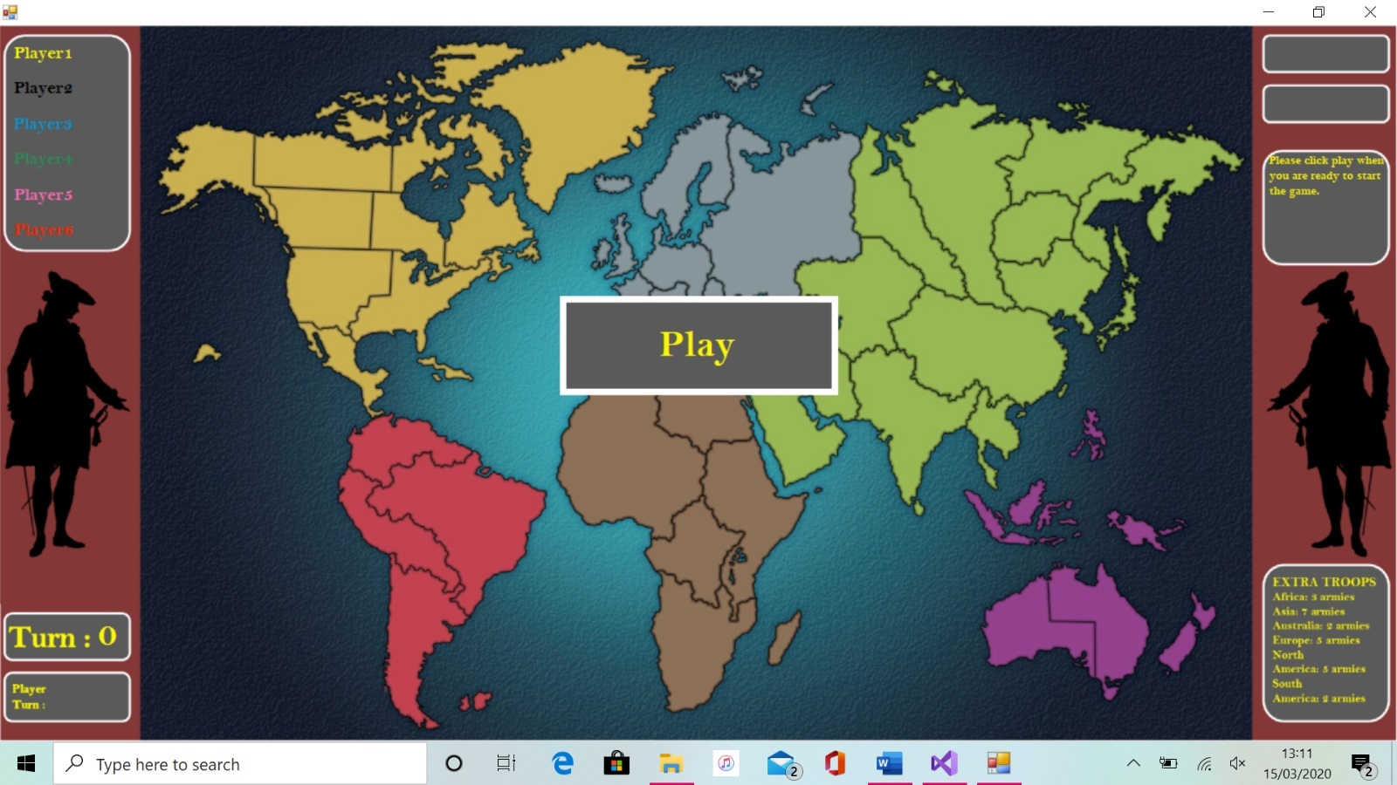

Label Turn

Label HelpText

Label Player[1-6]_Name

Button Play_Button

Figure 3.3

**Below figure 3.4 shows the game board UI after the play button has been clicked. This next stage allows the player to select the number of players that will be playing**

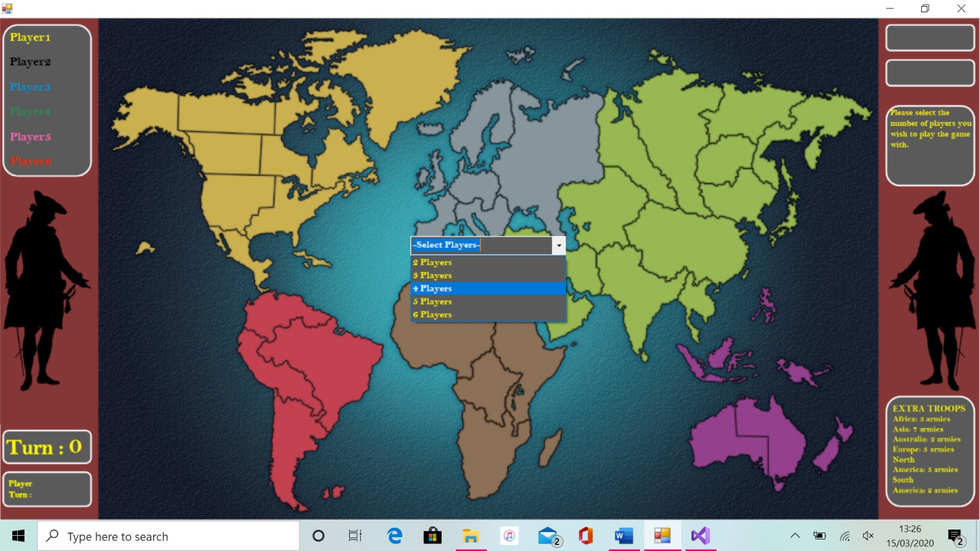

ComboBox Player_Selection_List

Figure 3.4

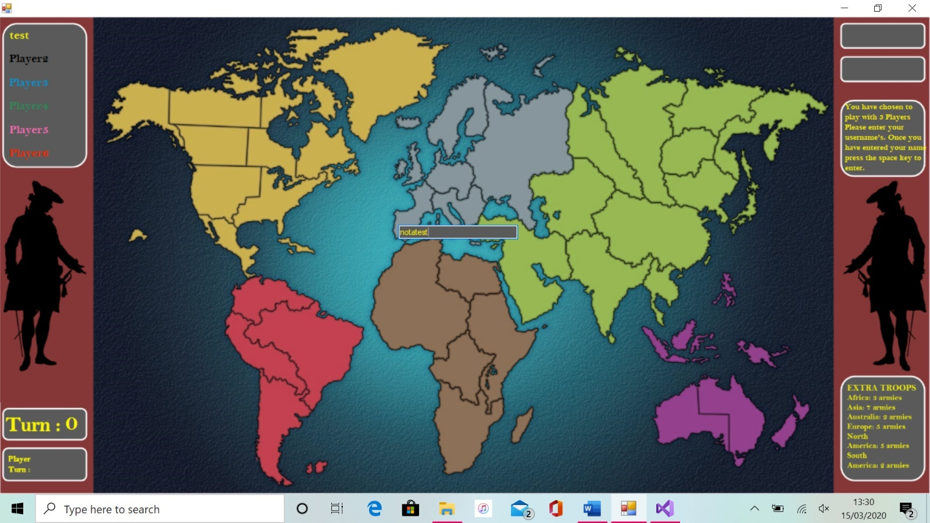**Then once the number of players is selected, the program will then allow you to input player names shown below in figure 3.5. As you will see, as the names are entered it will store them in the player name labels above in that players colour.**

TextBox Player_Name_Enter

Figure 3.5

Then once all players have entered their names, the advance game button will appear at the top right of the screen and once clicked will begin the game. In figure 3.6 you can see that the program will load up all of the region buttons and then allow the randomly selected first player to begin placing troops.

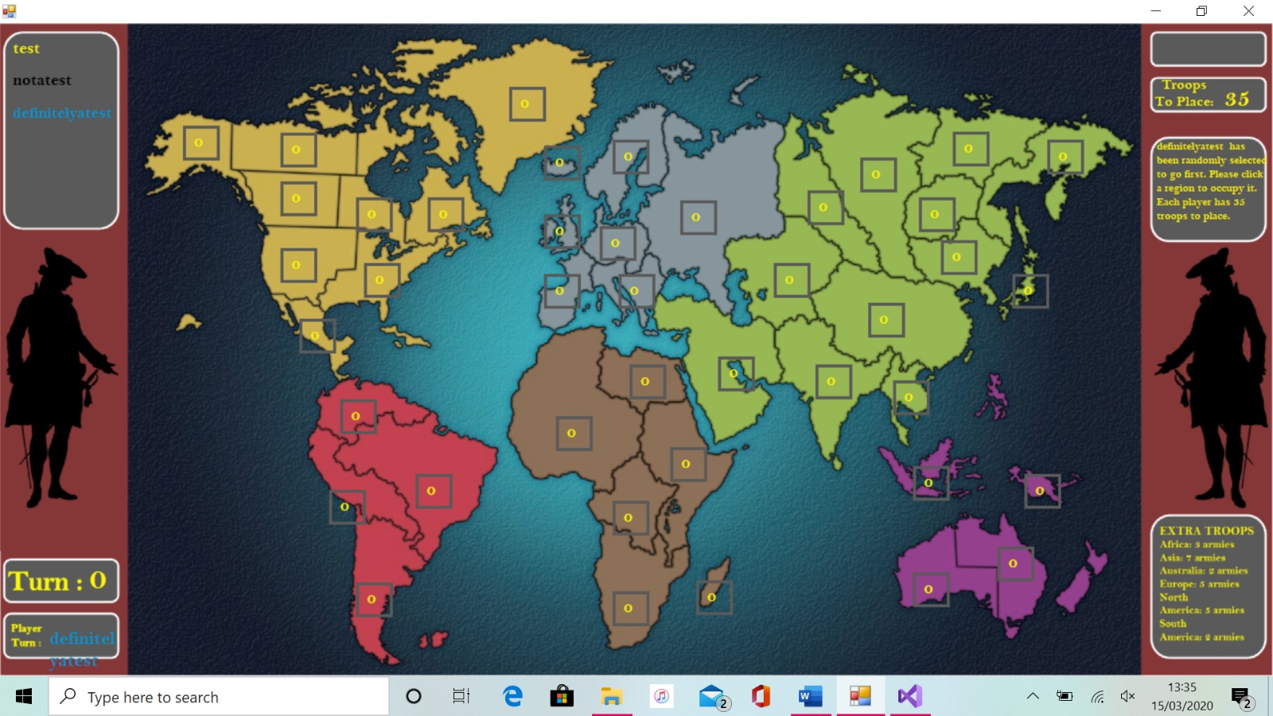

Label Troops_To_Place

Label PlayerTurn

Button “region name”

Figure 3.6

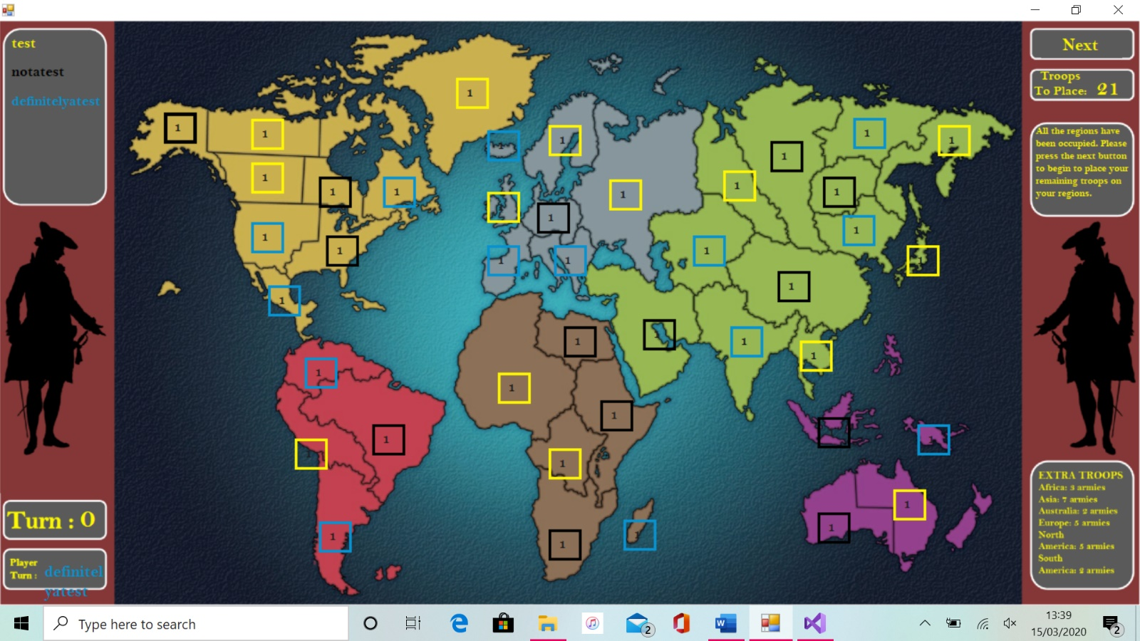The program will then cycle through allowing each player one by one to occupy a region. Once all regions have been occupied the program will disable the buttons and the advance game button will show, along with the player being prompted to click it. You can see this in figure 3.7.

Button Advance_Game

Figure 3.7

Once the advance game button has been clicked, the program will then allow each player one by one to place their remaining initial troops on the regions that they already occupy. Each time a region button is clicked, it will add 1 to the troops in that region while also taking 1 off the troops to place for that player. This is shown below in figure 3.8.

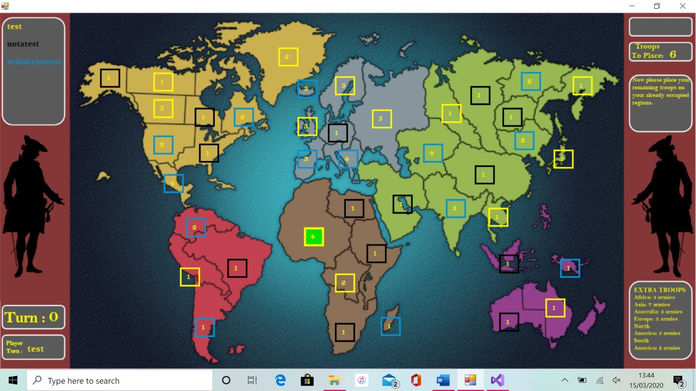

Figure 3.8

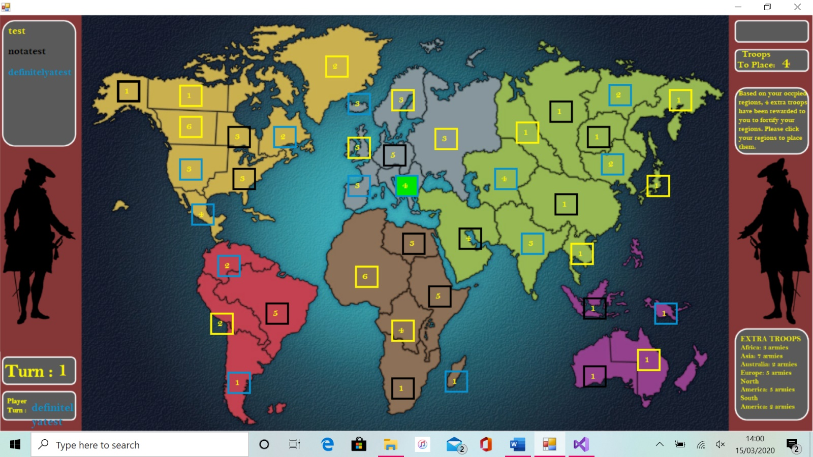Once all players have placed their remaining troops, the program will then prompt them to click the advance game button. Once this has been clicked , the program will go back to the randomly selected player and begin the turn cycle. Firstly, it will calculate the troops to place off that players occupied region and allow them to place the troops as can be seen in figure 3.9.

Figure 3.9

Once these troops have been placed, the program again will show the advance game button to allow the player to advance to the attack phase of their turn. Once this button has been clicked, the player will then be able to either click the advance game button again to advance onto the reinforce phase of their turn or click one of their regions to 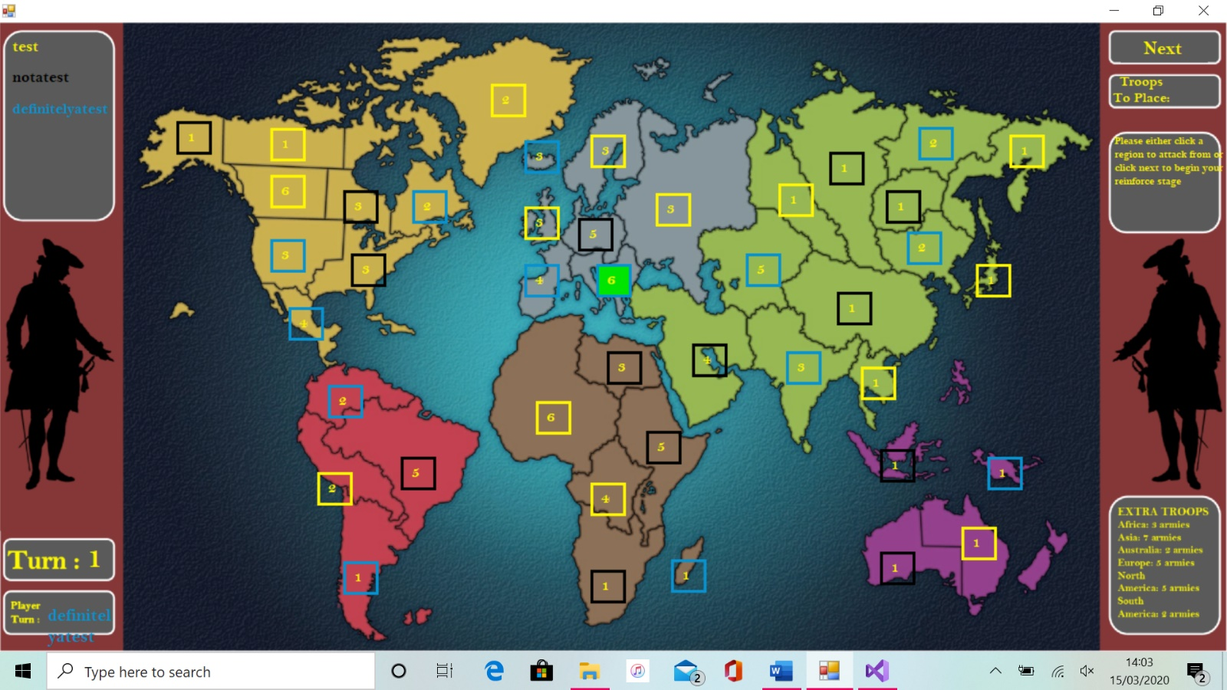attack from as long as it meets the pre-set conditions as can be seen in figure 3.10.

Figure 3.10

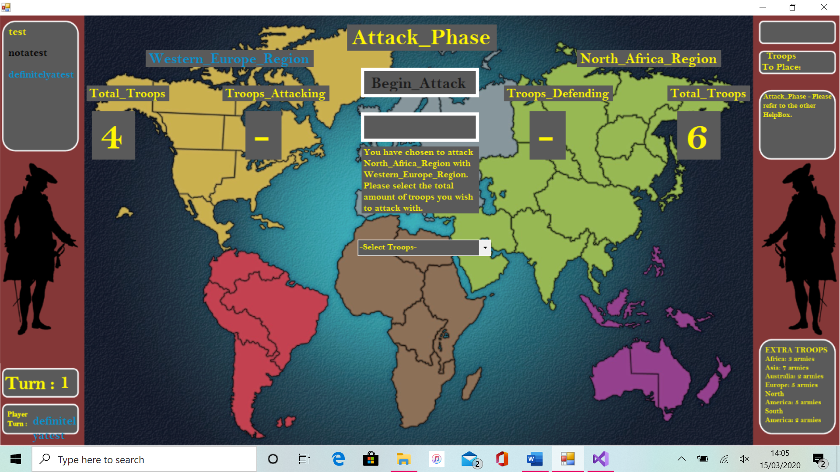If the player chooses to select one of their regions to attack from, they will then be able to select an enemy players adjacent region to click. Once they have done this the attack UI will display as is shown in figure 3.11.

ComboBox Select_Troops_To_Attack

Label Troops_”Attacking/Defending”_Number

Label Attack_HelpText

Label Defend_Region

Label Attack_Region

Label Total_Troops_”Attacking/Defending”_Number

Figure 3.11

Then once the player has selected the total troops they wish to attack from, a second ComboBox will appear prompting the player to select the number of troops (1-3 accordingly) they wish to attack with. Once this has been selected, the begin attack button will enable allowing the player to begin their attack as can be seen in figure 3.12.

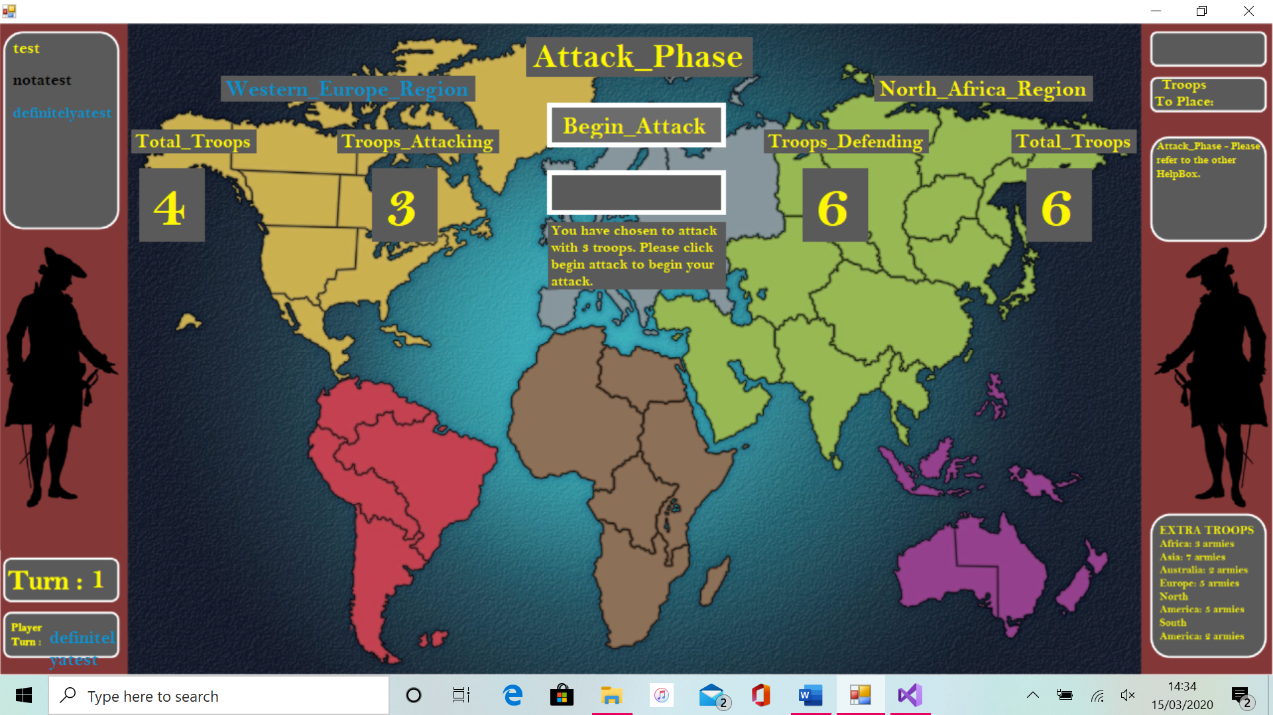

Figure 3.12

Button Next_Attack

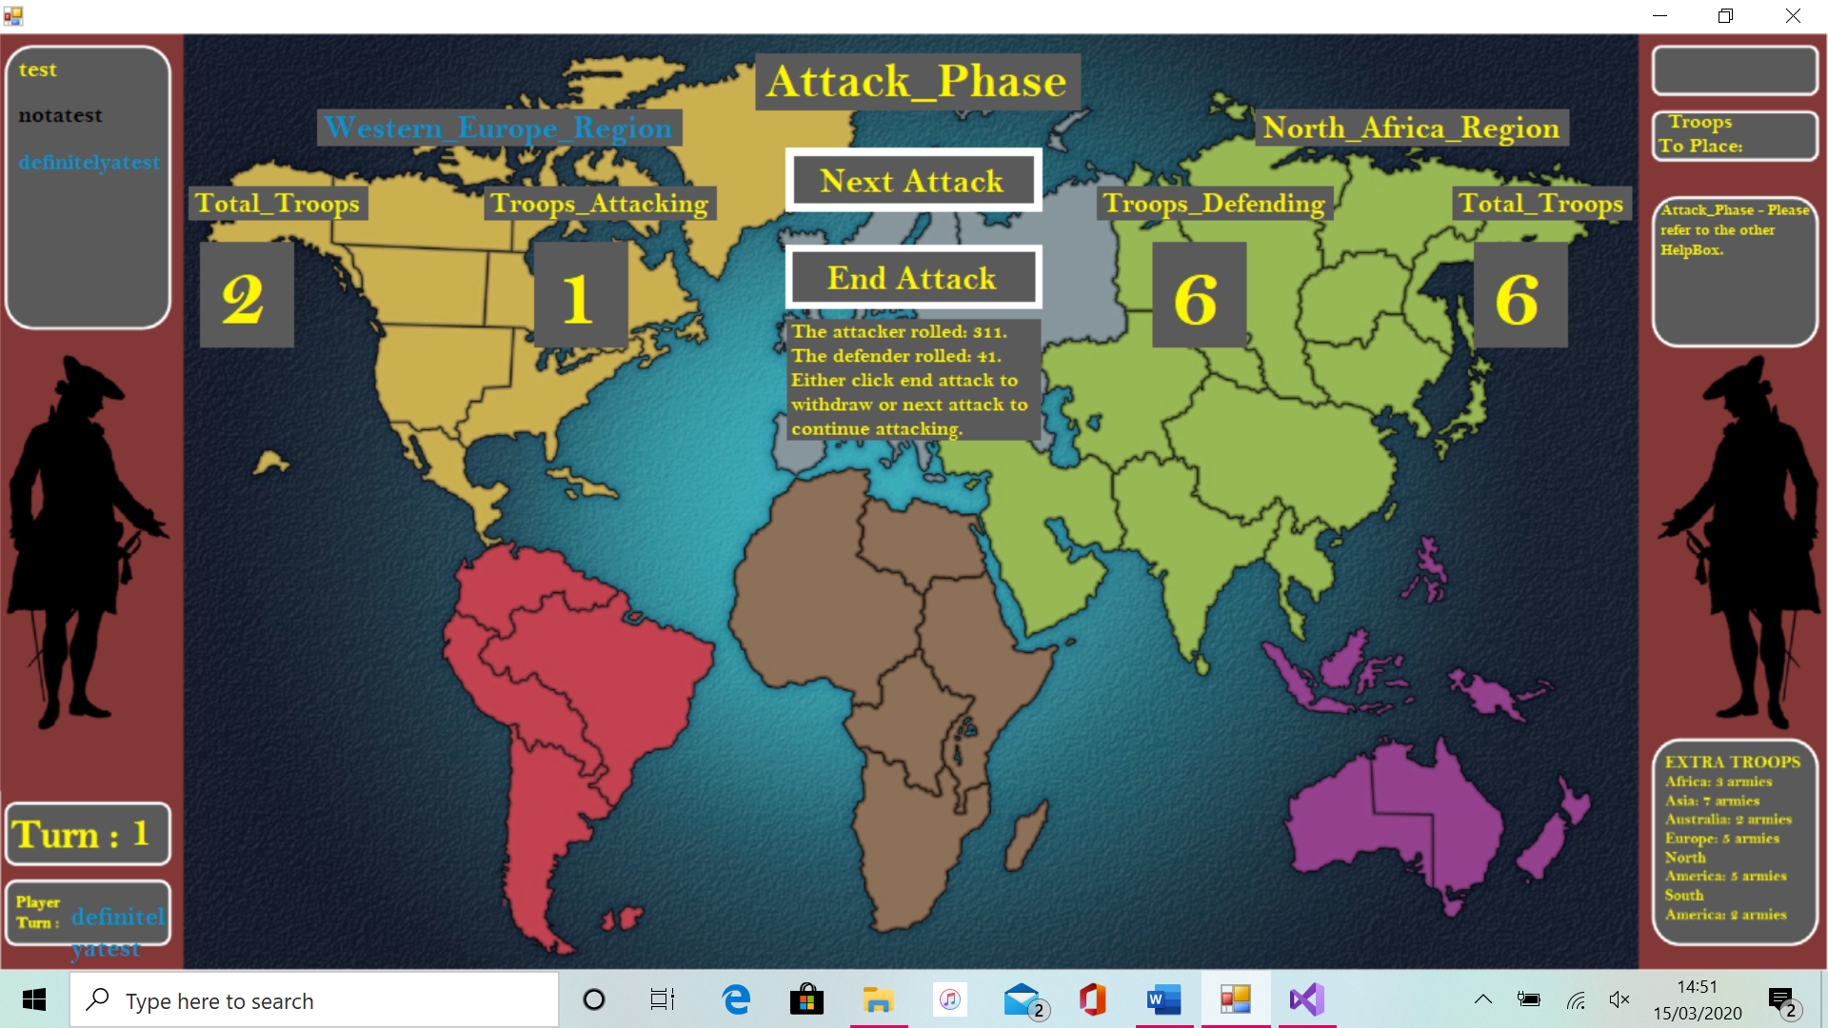Once the begin attack button has been clicked, the program will simulate 1 attack and then the user will have the option to click two buttons (unless either the attacker or defender have lost all their troops). Either to click the next attack button which will simulate another attack or end attack, which will end exit back to the game board. This is shown below in figure 3.13.

Figure 3.13

When the players clicks the end attack button they will be returned to the game board form and then will either be able to click another region to attack from or click the advance game button to advance to the reinforce phase of the players turn as is shown in figure 3.14.

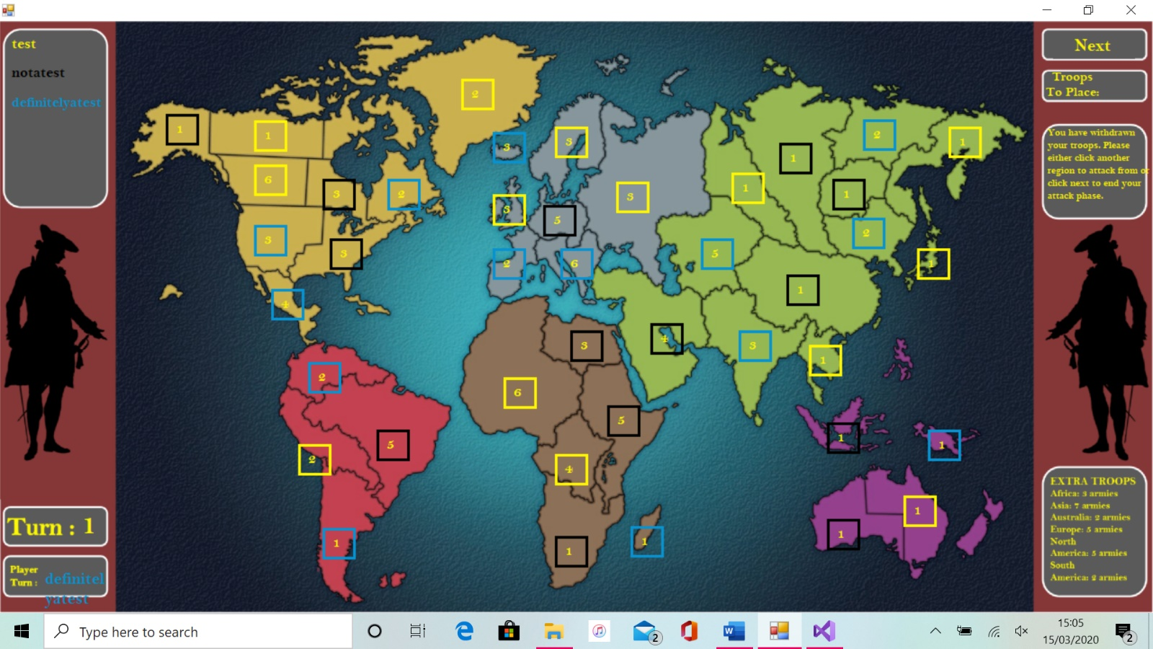

Figure 3.14

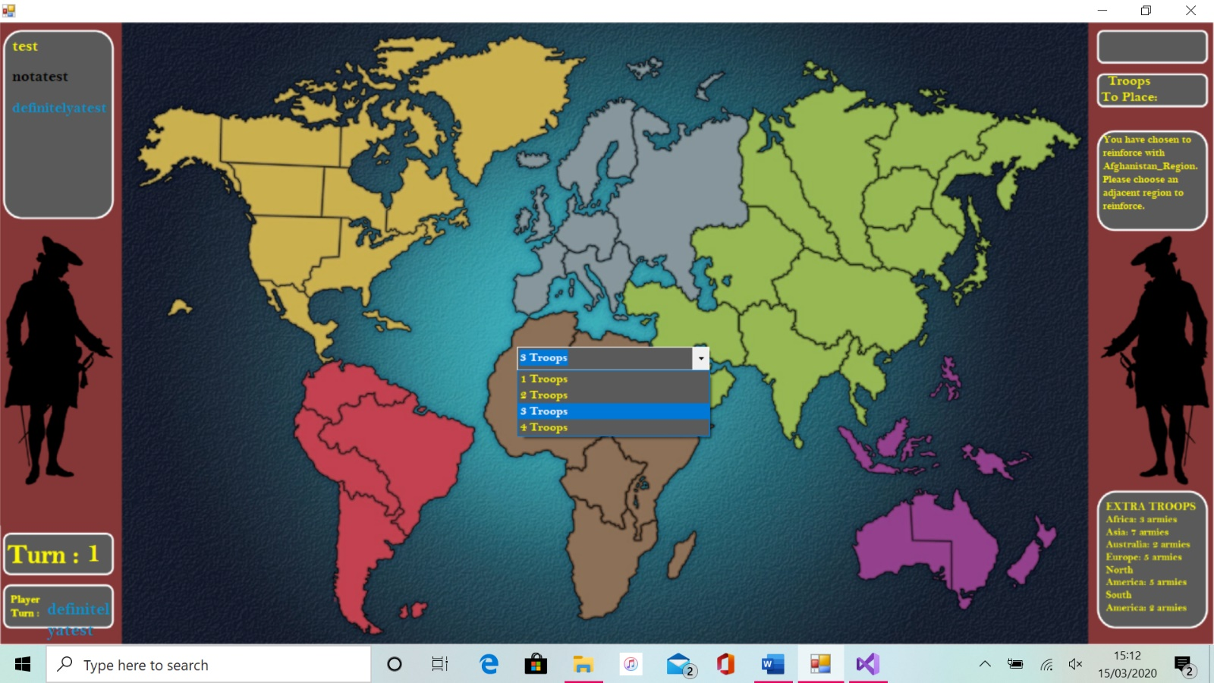Once in the reinforce phase of a players turn, a player can either click a region to reinforce from and then one to reinforce to. If they do this they will be given a prompt to ask how many troops they wish to reinforce with as can be seen in figure 3.15. If they choose not to reinforce and click the advance game button, it will progress to the next players turn.

Figure 3.15

The program will then continue to cycle through plays turns until the winning condition is met. When it has been met the winning screen will display and the game details will be saved to a file as can be seen in figure 3.16.

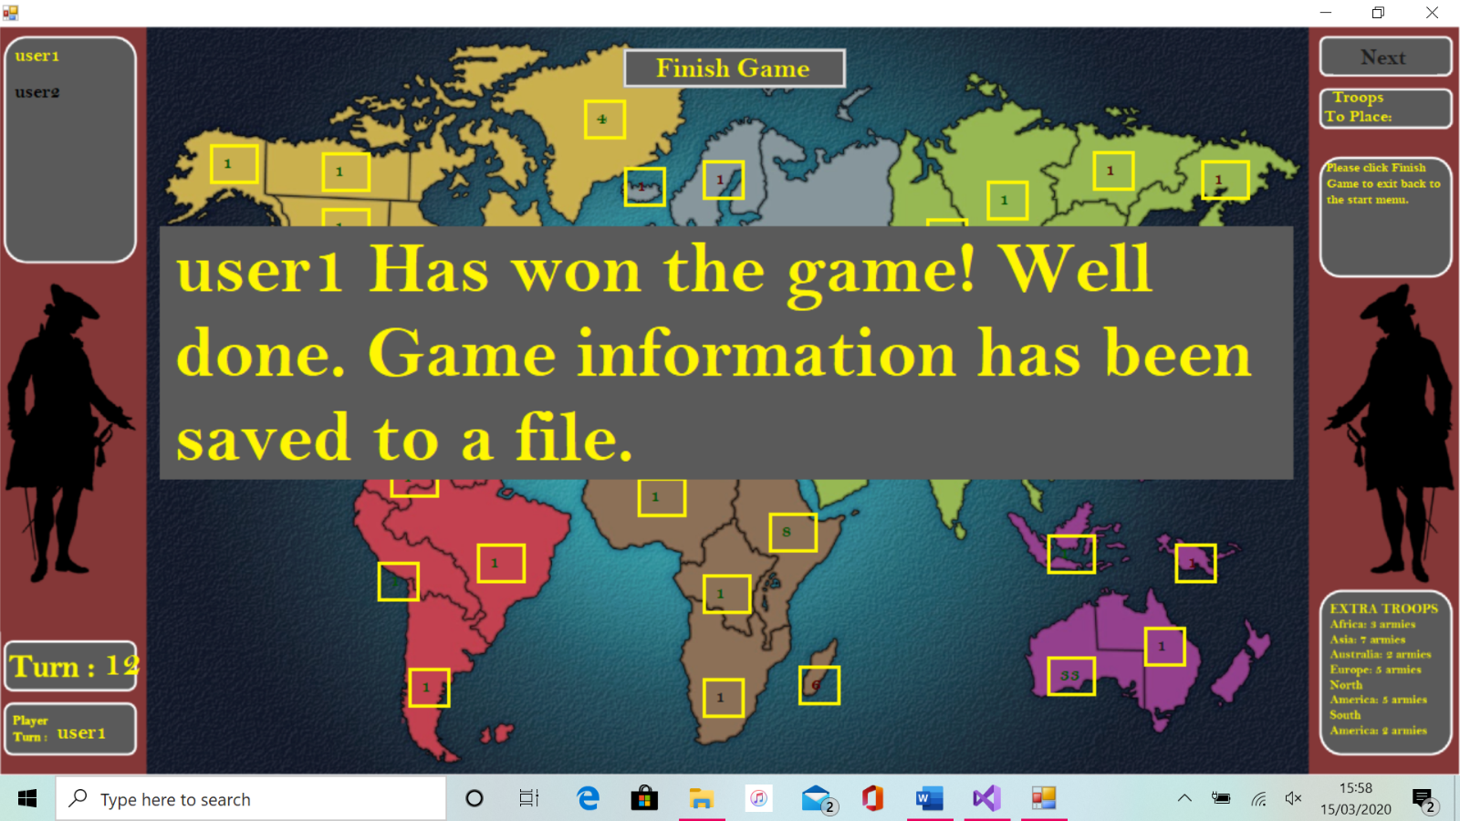

Button Finish_Game

Figure 3.16

**Once the player clicks the finish game button it will then exit back to the main menu screen where the player will again be given the option to start a new game, quit or load up the help text.**

**(3.5.7) Procedures and variables listings-**

**Below follows a table containing all function and variables within the program along with a short description of their purpose within the program.**

|  |  |  |
| --- | --- | --- |
| Functions (AdjacencyListRegion class) | Purpose | Variables used |
| public AdjacencyListRegions(int regions) | **Constructor method for creating new object of the AdjacencyListRegion class** | int regions  AdjacencyList = new LinkedList<Country>[regions]  int count = 0 |
| public void Add_Edge(Country Region1, Country Region2) | **Adds a region to the connected regions for a specified region** | Country Region1  Country Region2 |
| public void Add_Edge(Country Region1, Country Region2, Country Region3) | **“”** | Country Region1  Country Region2  Country Region3 |
| public void Add_Edge(Country Region1, Country Region2, Country Region3, Country Region4) | **“”** | Country Region1  Country Region2  Country Region3  Country Region4 |
| public void Add_Edge(Country Region1, Country Region2, Country Region3, Country Region4, Country Region5) | **“”** | Country Region1  Country Region2  Country Region3  Country Region4  Country Region5 |
| public void Add_Edge(Country Region1, Country Region2, Country Region3, Country Region4, Country Region5, Country Region6) | **“”** | Country Region1  Country Region2  Country Region3  Country Region4  Country Region5  Country Region6 |
| public void Return_Regions(ref string text) | **Will store the regions that a region can reach in the string that is passed by reference** | string text  int count = 0  LinkedList<Country> list  Country connection |
| public void Store_Regions (ref List<Country> list) | **Will store the regions that a region can reach in a list of the country class objects** | List<Country> list  int count = 0  LinkedList<Country> list_regions  Country connection |

|  |  |  |
| --- | --- | --- |
| Functions (Country class) | Purpose | Variables used |
| public Country(String name) | **Constructor method for creating new object of] the Country class** | String name  private string Name  private int Troops |
| public void Change_Occupier(Player player) | **Changes the occupier attribute for that region** | private Player Occupier |
| public void Add_Troops(int TroopsToAdd) | **Adds troops to the troop attribute for that region** | int TroopsToAdd  private int Troops |
| public void Remove_Troops(int TroopsToRemove) | **Removes troops from troop attribute for that region** | int TroopsToRemove  private int Troops |
| public int Output_Troops() | **Returns the troop attribute from the specified region** | private int Troops |
| public Player Output_Player() | **Returns the player attribute from the specified region** | private Player Occupier |
| public string Output_Name() | **Returns the name attribute from the specified region** | private string Name |

|  |  |  |
| --- | --- | --- |
| Functions (Player class) | Purpose | Variables used |
| public Player(string name, int r, int g, int b) | **Constructor method for creating a new object of the Player class** | Player_Name = name  Player_Colour[0] = r  Player_Colour[1] = g  Player_Colour[2] = b |
| public string Output_Player_Name() | **Returns the player name attribute for the specified player** | private string Player_Name |
| public int Output_Colour (int colour_position) | **Returns the rgb values for the specified players colour** | private int[] Player_Colour  int colour_position |
| public void Add_Region(string region) | **Adds a region to the players list of occupied regions** | string region  public List<string> Occupied_Regions |
| public void Remove_Region(string region) | **Scans the players list of occupied regions and if found removes it from the list.** | string region  int count = 0  string regions  public List<string> Occupied_Regions |
| public void Set_Troops (int troops) | **Sets a players Troops_To_Place attribute** | int troops  private int Troops_To_Place |
| public void Add_Troops(int troops) | **Adds troops to a players Troops_To_Place attribute** | int troops  private int Troops_To_Place |
| public int Output_Troops () | **Returns the Troops_To_Place attribute for a specified player** | private int Troops_To_Place |

|  |  |  |
| --- | --- | --- |
| Functions (GameBoard form) | Purpose | Variables used |
| private void Hide_Attack_Phase() | **Hides all the form controls with the tag “Attack_Phase”** | Control form |
| private void Disable_Buttons() | **Disables all the form controls with the tag “Country”** | Control form |
| private void Enable_Buttons() | **Enables all the form controls with the tag “Country”** | Control form |
| private void Show_Buttons() | **Shows all the form controls with the tag “Country”** | Control form |
| private void Hide_Buttons() | **Hides all the form controls with the tag “Country”** | Control form |
| private void Check_Occupier(List<Country> continent, int troops) | **Checks all the regions in the continent list (of Country class objects) then if a players occupied regions list contains them all, it returns true** | List<Country> continent  int troops  bool flag  Country country  Players_In_Game[Current_Player] |
| private void Check_Troops_Remaining_Fortify() | **Checks the Troops_To_Place attribute in a player object. If this is 0 then the function will make appropriate changes.** | private int Troops_To_Place  Players_In_Game[Current_Player] |
| private void Update_Region_Fortify(Button region) | **Updates a specified button control to add 1 troop to it during the fortify phase** | Button region  Players_In_Game[Current_Player] |
| private void Update_Region(Button region) | **Updates a specified button control to add 1 troop to it during the initial troop placement phase** | Button region  Players_In_Game[Current_Player] |
| private void Set_Troops(int troops, int playernum) | **Sets the Troops_To_Place for a specified number of players** | int troops  Players_In_Game[count]  int playernum  int count |
| private void Check_Region(Button regions) | **Checks if a specified region is in a players list of occupied regions. If it is, it will set the back colour of that region to green or if not, it will set it to red** | Button regions  Players_In_Game[Current_Player]  string region |
| private void Claim_Region(Button region) | **During the initial set-up of the game will make all the necessary changes needed when a player first occupies a region** | Button region  Players_In_Game[Current_Player] |
| private void Next_Player() | **Moves to the next player’s turn and changes** | Int Current_Player  Players_In_Game[Current_Player] |
| private void Check_Troops_Remaining() | **During the initial set-up of the game will check if Troops_To_Place is 0. If it is, then the function will run the Next_Player function** | Players_In_Game[Current_Player] |
| private void Comparing_Dice_Rolls(int dice, ref string winner) | **Compares the attacker and defender dice roll then sets the winner variable to either “Attacker” or “Defender”** | int dice  ref string winner  List <int> Attacker_Dice_Rolls[dice]  List <int> Defender_Dice_Rolls[dice] |
| private void Check_Attack_Win() | **Checks if a defender or attacker has no troops remaining. If so will carry out the appropriate actions for either case** | Players_In_Game[Current_Player]  Int Game_State |
| private void Attack_Update(string winner) | **Takes winner as an input. Depending on if the winner if the attacker or not, the function will carry out the appropriate actions** | string winner  Country Country_Selected_Defend  Country Country_Selected_Attack |
| private void Attacker_Dice_Roll_3() | **Rolls 3 attacker dice** | int Attack_Dice1  int Attack_Dice2  int Attack_Dice3  List <int> Attacker_Dice_Rolls |
| private void Attacker_Dice_Roll_1() | **Rolls 1 attacker die** | int Attack_Dice1  List <int> Attacker_Dice_Rolls |
| private void Defender_Dice_Roll_2() | **Rolls 2 defender dice** | int Defend_Dice1  int Defend_Dice2  List <int> Defender_Dice_Rolls |
| private void Defender_Dice_Roll_1() | **Rolls 1 defender die** | int Defend_Dice1  List <int> Defender_Dice_Rolls |

# Section 4 – Testing

**I have split my testing into 3 main parts. The first part is a list of errors or problems that I found while testing my code as I programmed it and how I went about fixing these. The second part is my test plan and what things I will be testing when I run and record my program. Finally, will be …**

**(4.1) Testing while programming-**

**The first problem I faced was that as I was going through testing the game, I noticed that after a phase of the game was completed and then before the player clicked the next button which would advance to the next part, the player would still be able to carry on placing troops or just clicking the region button even to a point that they would go into negative troops to place. To fix this I had to disable all the region button controls until the game state would advance at certain points of the game in between the player finishing that phase and then clicking the advance game button.**

**A second big problem I encountered when trying to get the attack phase to work was to get a way to search the selected region and then store the regions adjacent to it to later be able to select to attack. To get around having to search through the array of linked list and then through each specific list, I wrote into the adjacency list regions class a new function that allowed a list to be passed through it by reference and then which would store the regions adjacent to the selected one in that list so that I could then use it in the next game state when selecting where to attack. During this I had to go back and add the region names to be region and then “_region” as this was the format that the linked list region names were under and would only be able to be used if they were the same. Once this was adjusted and tested for the mouse enter event, the same process could then be implemented for the mouse click event.**

**The third big issue I encountered while coding the attack phase was that I wanted to change the colour of the region names that are in the attack to the corresponding players colour. While this was easy to do with the current player using the same method I had used previously using the players in game list and current player int, I couldn’t see an easy way of getting the colour values from the player class through the “players in game” list as there was no way of knowing which player occupied the other region. And so, to solve this I changed the occupier data field to be one of the Player class and therefore it could access the Player class of the player that occupied that region through the Country class itself. That then allowed me to use the region to access the players colour.**

**While programming this part I also realised another problem was that later on in the game when a region couldn’t reach any enemy regions it would still be able to be clicked by the player and thus cause the game to not be able to progress any further. Firstly, I had to fix this issue for the Mouse Enter function of each button so that it highlighted that region red if it was surrounded by only that players regions. Once this was completed it would just be a matter of using the same conditions for the Mouse Click function.**

**As well as this was another issue connected to this which was that when comparing the player that occupied the region through the List “Reachable Regions” they were inputted as strings from the Reachable Regions of each region and not the Country class. To solve this, I had to go back to the AdjacencyListRegions class and change it so that it was a list of linked lists of the Country class. I then also had to go back and edit where each region added the regions it could reach and change the inputs to objects of the Country class instead of strings. Once this change was made, I then had to go back through and quickly edit the MouseEnter and MouseClick functions so it worked for the list of reachable regions being of the Country class rather than the strings.**

**During running the actual attack phase, I noticed all the attackers die and all the defenders die were the same number e.g. 444 & 22. To solve this, I had to create the Random variable outside the function then call the next function to get the next random variable which forced the program to create a new random variable instead of just using the last again.**

**The next issue I faced while running this part of the code was that the .Sort function which would sort a list from smallest to largest whereas I needed the list in largest to smallest and so quickly found a solution. It was very simple to fix as just needed the .reverse() function applying to the lists of dice rolls.**

**(4.2) Test plan-**

**Below is a test plan to test all aspects and algorithms of the program work as expected. Any corrective action will be documented, and the tests will be carried out using screen capture software. Please note that when the program opens up the game board form the recoding software suspends as is the same when clicking the quit button, these were the only problems, but could not be fixed. Most of the testing that has been carried out in this test plan will be Black-box testing. This is concerned with testing that interactions with the interface produce the expected outputs. As well as this, for the phases of a players turn I will use Module testing to test that the individual components of a system (functions etc) work as expected.**

|  |  |  |  |  |  |
| --- | --- | --- | --- | --- | --- |
| Test Number | Test Data | Test | Expected result | Actual Result | Corrective Action |
| 1 | **N/A** | **New_Game button functions correctly** | **Opens the GameBoard form and starts a new game** | **As Expected** | **N/A** |
| 2 | **N/A** | **Quit button functions correctly** | **Exits the program** | **As Expected** | **N/A** |
| 3 | **N/A** | **Help button functions correctly** | **Displays the help menu** | **As Expected** | **N/A** |
| 4 | **N/A** | **Play Button advances to selecting players** | **Displays the select players ComboBox** | **As Expected** | **N/A** |
| 5 | **Selecting ComboBox** | **ComboBox allows you to select 2 players** | **Selects 2 players** | **As Expected** | **N/A** |
| 6 | **Selecting ComboBox** | **ComboBox allows you to select 3 players** | **Selects 3 players** | **As Expected** | **N/A** |
| 7 | **Selecting ComboBox** | **ComboBox allows you to select 3 players** | **Selects 4 players** | **As Expected** | **N/A** |
| 8 | **Selecting ComboBox** | **ComboBox allows you to select 4 players** | **Selects 5 players** | **As Expected** | **N/A** |
| 9 | **Selecting ComboBox** | **ComboBox allows you to select 5 players** | **Selects 6 players** | **As Expected** | **N/A** |
| 10 | **No input**  **Numbers = 3849392**  **Letters = test**  **Symbols = !()’**  **Mix = test1!**  **Name of any length** | **That a player can choose to enter no name, one with letters, numbers, a mix and that it can be any length** | **Stores “ “ as name**  **Stores 3849392 as name**  **Stores test as name**  **Stores !() as name**  **Stores test1! As name**  **Stores name with appropriately sized label** | **As Expected** | **N/A however could possibly add a limit to the character size however since labels are sized accordingly this isn’t necessary.** |
| 11 | **N/A** | **That the game will begin as intended, loading up the region buttons** | **Loads up region buttons** | **As Expected** | **N/A** |
| 12 | **N/A** | **Able to click region to occupy it**  **Will advance player after a region is occupied**  **Cannot click region that is already occupied** | **Will highlight the region in the players colour**  **Players turn will advance to the next player**  **Will not allow the player to occupy the region** | **As Expected** | **N/A** |
| 13 | **N/A** | **That Troops_To_Place reduces as regions are occupied** | **Troops_To_Place reduces by 1 when a region is occupied** | **As Expected** | **N/A** |
| 14 | **N/A** | **That the program will recognise when all regions have been occupied** | **Disable all region buttons and prompt player to advance game** | **As Expected** | **N/A** |
| 15 | **N/A** | **That the program begins the remaining troops placement when the advance game button is clicked** | **Enables buttons and begins allowing player to place remaining troops** | **As Expected** |  |
| 16 | **N/A** | **That the “game state 1” functions works correctly for the mouse enter and mouse click events** | **Should highlight green if mouse enters occupied region**  **Should highlight red if mouse enters unoccupied region**  **Should add one troop to occupied region if clicked**  **Should do nothing if unoccupied region is clicked** | **As Expected** | **N/A** |
| 17 | **N/A** | **That when a player has placed all remaining troops it goes to the next player** | **Changes player turn to next player** | **As Expected** | **N/A** |
| 18 | **N/A** | **When all remaining troops are placed, the timer function works as intended and moves to the next stage of the game** | **Recognises all troops have been placed and prompts the player to begin player turn cycle** | **As Expected** | **N/A** |
| 19 | **N/A** | **When the advance game button is clicked it will begin the player turn cycle** | **Goes back to player selected at the beginning of the game and starts fortify phase** | **As Expected** | **N/A** |
| 20 | **6 players**  **4 players**  **2 players** | **Calculates Troops_To_Place correctly** | **Should display 3 Troops_To_Place**  **Should display 3 Troops_To_Place**  **Should display 7 Troops_To_place** | **As Expected** | **N/A** |
| 21 | **N/A** | **That the “game state 2” functions works correctly for the mouse enter and mouse click events** | **Should highlight green if the region is occupied by the player and red if it isn’t. If clicked and occupied by the player should add 1 troop to that region. If not occupied should do nothing** | **As Expected** | **N/A** |
| 22 | **N/A** | **When all fortifying troops have been placed the timer function runs and the user is prompted to click the advance game button** | **Advance game button will appear and buttons will be disabled** | **As Expected** | **N/A** |
| 23 | **N/A** | **When the advance game button is clicked the program moves onto the attack phase of the game** | **Buttons will enable and help text will prompt user on attack phase** | **As Expected** | **N/A** |
| 24 | **N/A** | **That the “game state 3” functions works correctly for the mouse enter and mouse click events** | **Should highlight green any region that has more than 2 troops green and 1 troop red. Should not be able to click regions with less than 1 troop** | **As Expected** | **N/A** |
| 25 | **N/A** | **“”** | **Should highlight enemy regions in red and not allow a player to click these.** | **As Expected** | **N/A** |
| 26 | **N/A** | **“”** | **Should highlight in red any player regions that cannot reach an enemy adjacent region and not allow a player to click these** | **As Expected** | **N/A** |
| 27 | **N/A** | **A region following the conditions set in the functions for “Game state 3” can be selected** | **Green border appears around selected region and help text reads that it has been selected** | **As Expected** | **N/A** |
| 28 | **N/A** | **That the “game state 3” functions works correctly for the mouse enter and mouse click events** | **Should highlight red any player regions adjacent or otherwise and not allow the player to click these** | **As Expected** | **N/A** |
| 29 | **N/A** | **“”** | **Should highlight red any enemy regions not adjacent to the selected one and not allow the player to click these** | **As Expected** | **N/A** |
| 30 | **N/A** | **“”** | **Should highlight green any enemy regions adjacent to the selected one and allow a player to click them. Which then loads up the attack UI** | **As Expected** | **N/A** |
| 31 | **Western United states region (black player)**  **Eastern United states region (yellow player)**  **Left (5)**  **Right (3)** | **That the attack UI displays correctly when it loads** | **Region on left highlighted in players colour (black)**  **Region on right highlighted in enemy players colour**  **(yellow)**  **Total troops for each is the total troops on each of the regions** | **As Expected** | **N/A** |
| 32 | **Total troops = 5** | **That the ComboBox displays the correct number of troops to select from** | **Should allow you to select from 1 – the number of troops 1 less than the total (4)** | **As Expected** | **N/A** |
| 33 | **Selected troops = 1**  **Selected troops = 5**  **Selected troops = 20** | **That when selecting from the ComboBox it displays the correct number of troops on the troops attacking/defending label** | **Troops attacking should he the selected number of troops and troops defending should always be the total troops in the defending region** | **As Expected** | **N/A** |
| 34 | **Selecting 1 troop** | **That when selecting from the ComboBox it allows you to select 1 troop and displays this on the attack help text** | **Attack help text displays that you have chosen to attack with 1 troop** | **As Expected** | **N/A** |
| 35 | **Selecting 2 troops** | **That when selecting from the ComboBox it allows you to select 2 troops and displays this on the attack help text** | **Attack help text displays that you have chosen to attack with 2 troops** | **As Expected** | **N/A** |
| 36 | **Selecting 3 troops** | **That when selecting from the ComboBox it allows you to select 3 troops and displays this on the attack help text** | **Attack help text displays that you have chosen to attack with 2 troops** | **As Expected** | **N/A** |
| 37 | **N/A** | **That the dice roll and comparison algorithm (attacking algorithm) functions as is expected** | **When rolling 1 attacking dice the defender defends with 1** | **As Expected** | **N/A** |
| 38 | **N/A** | **“”** | **When rolling 2 attacking dice the defender defends with 1** | **As Expected** | **N/A** |
| 39 | **N/A** | **“”** | **When rolling 3 attacking dice the defender defends with 1 (if they don’t have 2 or more troops)** | **As Expected** | **N/A** |
| 40 | **N/A** | **“”** | **When rolling 3 attacking dice the defender defends with 2 (if they have 2 or more troops)** | **As Expected** | **N/A** |
| 41 | **Attacker dice rolls –**  **632**  **Defender dice rolls-**  **32** | **That the comparing dice rolls works as intended for 3 vs 2** | **If the attacker wins defender looses 1 troops and if the defender wins the attacker loses 1 troop.** | **As Expected – Defender loses 2 troops** | **N/A** |
| 42 | **Attacker wins first attack**  **Attacker dice rolls –**  **41**  **Defender dice rolls-**  **4** | **That the comparing dice rolls work as intended for 2 vs 1** | **“”** | **As Expected – Defender loses 1 troop**  **Attacker loses 1 troop** | **N/A** |
| 43 | **N/A** | **That clicking end attack after the first attack works as intended** | **Should exit back and display that the player has withdrawn** | **As Expected** | **N/A** |
| 44 | **N/A** | **That when clicking the advance game button on the attacking phase it will advance to the reinforce stage** | **Should display that the player has entered the reinforce phase of their turn** | **As Expected** | **N/A** |
| 45 | **N/A** | **That you can advance to the reinforce stage without attacking** | **When a player enters the attacking phase can click the advance turn button straight away** | **As Expected** | **N/A** |
| 46 | **N/A** | **That the “game state 5” functions works correctly for the mouse enter and mouse click events** | **Should highlight green any region with 2 or more troops in it and red for any that have 1** | **As Expected** | **N/A** |
| 47 | **N/A** | **“”** | **Should highlight red any region that cannot reach an adjacent region also occupied by the player** | **As Expected** | **N/A** |
| 48 | **N/A** | **“”** | **Player should not be able to click region that do not follow the conditions set in test 46 and test 47** | **As Expected** | **N/A** |
|  |  |  |  |  |  |
|  |  |  |  |  |  |
|  |  |  |  |  |  |
|  |  |  |  |  |  |

# Section 5 - Evaluation

**Include any end user testing and overall summary of how well the program met each of the objectives**

**End-User/Evaluation**

**Vanessa – As someone who doesn’t play computer games. She found it easy to play and that it was quite intuitive for new players with the help text box. Improve possibly design features (Box coloured rather than border).**

**Rory – Change help text so that it tells you to enter name before you start entering it. Fixed this by changing the prompt to appear after you select the number of players. INCLUDE IN TEXTING**

**Include oversees connections between regions to show where they can attack**

**Alex – If regions are clicked too quickly then it goes over as the tick timer doesn’t have chance to check – Fix = make tick timer shorter so it checks quicker. Likes aesthetics of the game (UI) easy to use.**

**Adam – Deselect option when attacking and fortifying if clicked wrong first region. Not played risk but found it intuitive and UI easy to use**

**Zak – Liked representation of risk. Again, hadn’t played risk before and found it easy to get the hang off. Wanted deselect options again for attacking. Option prompt to confirm username.**